Nguyễn Việt Hoàng

B22DCVT214

1. Docker Basic Commands

Check Docker version with docker --version

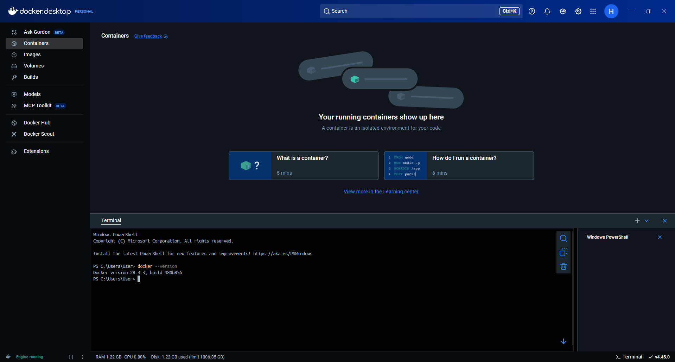

List running containers with docker ps

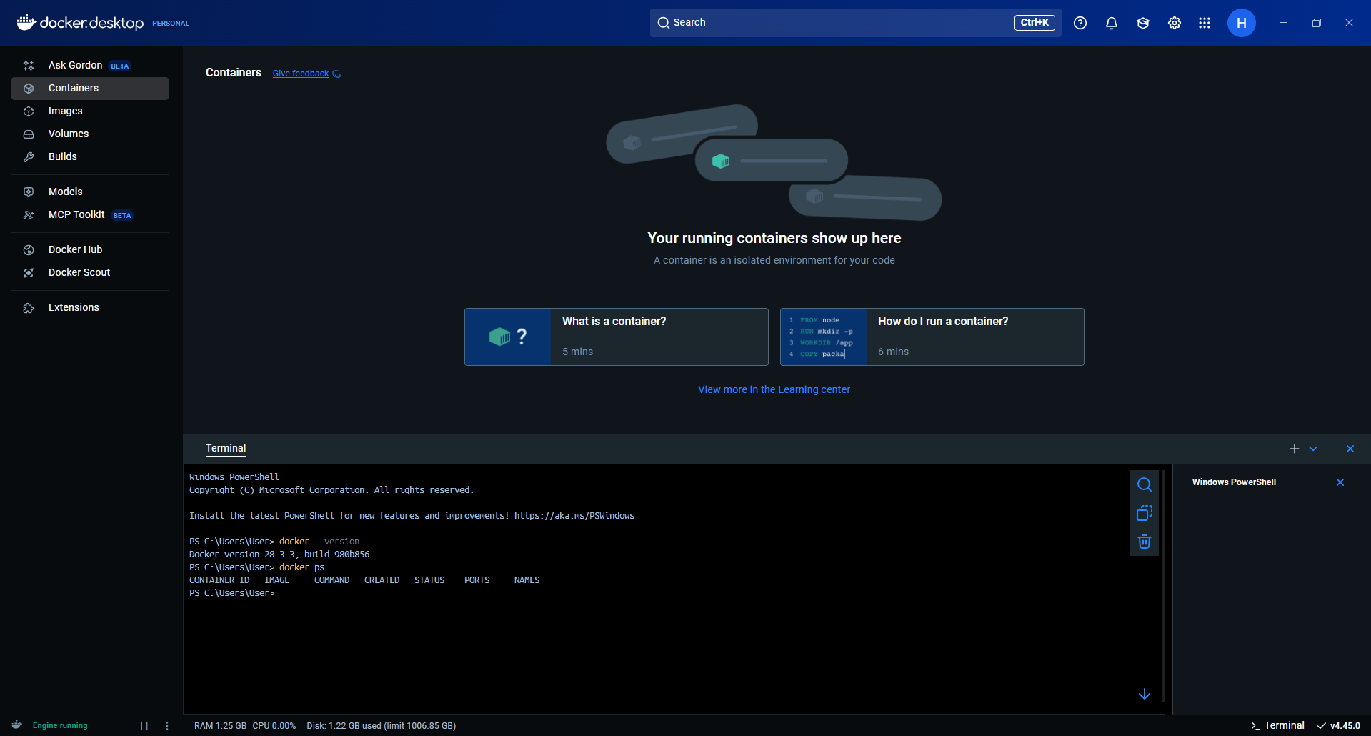

List all containers (including stopped) with docker ps -a

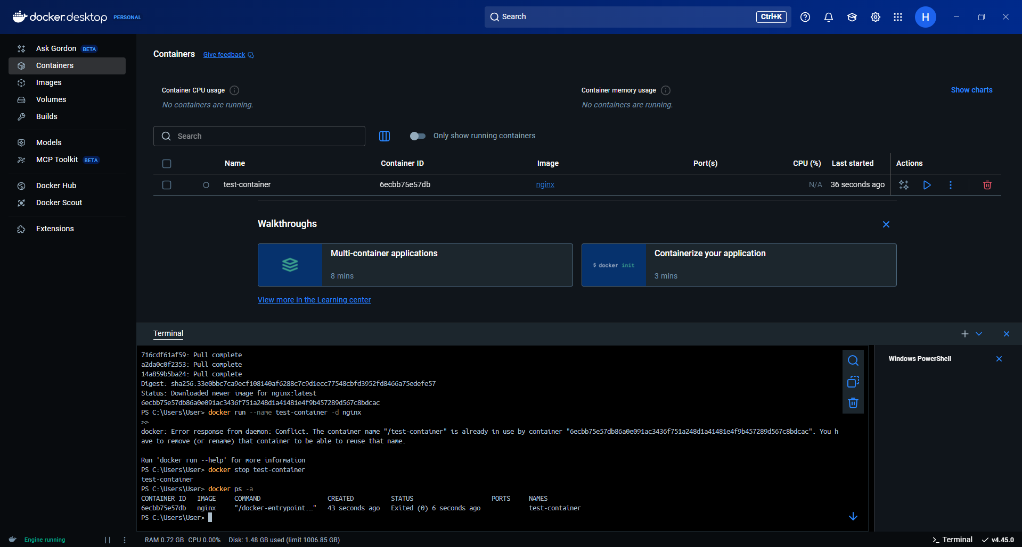

Start a container

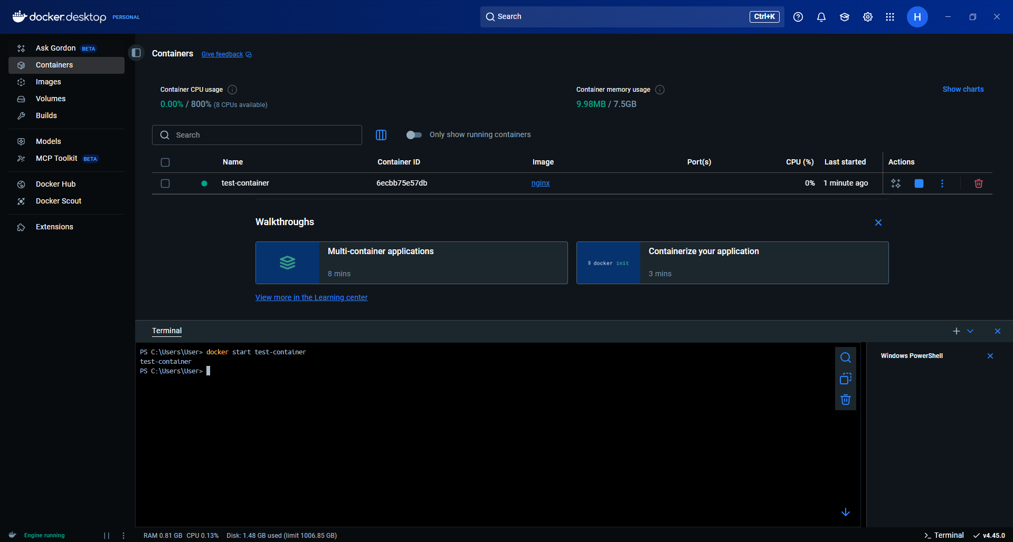

Stop a container

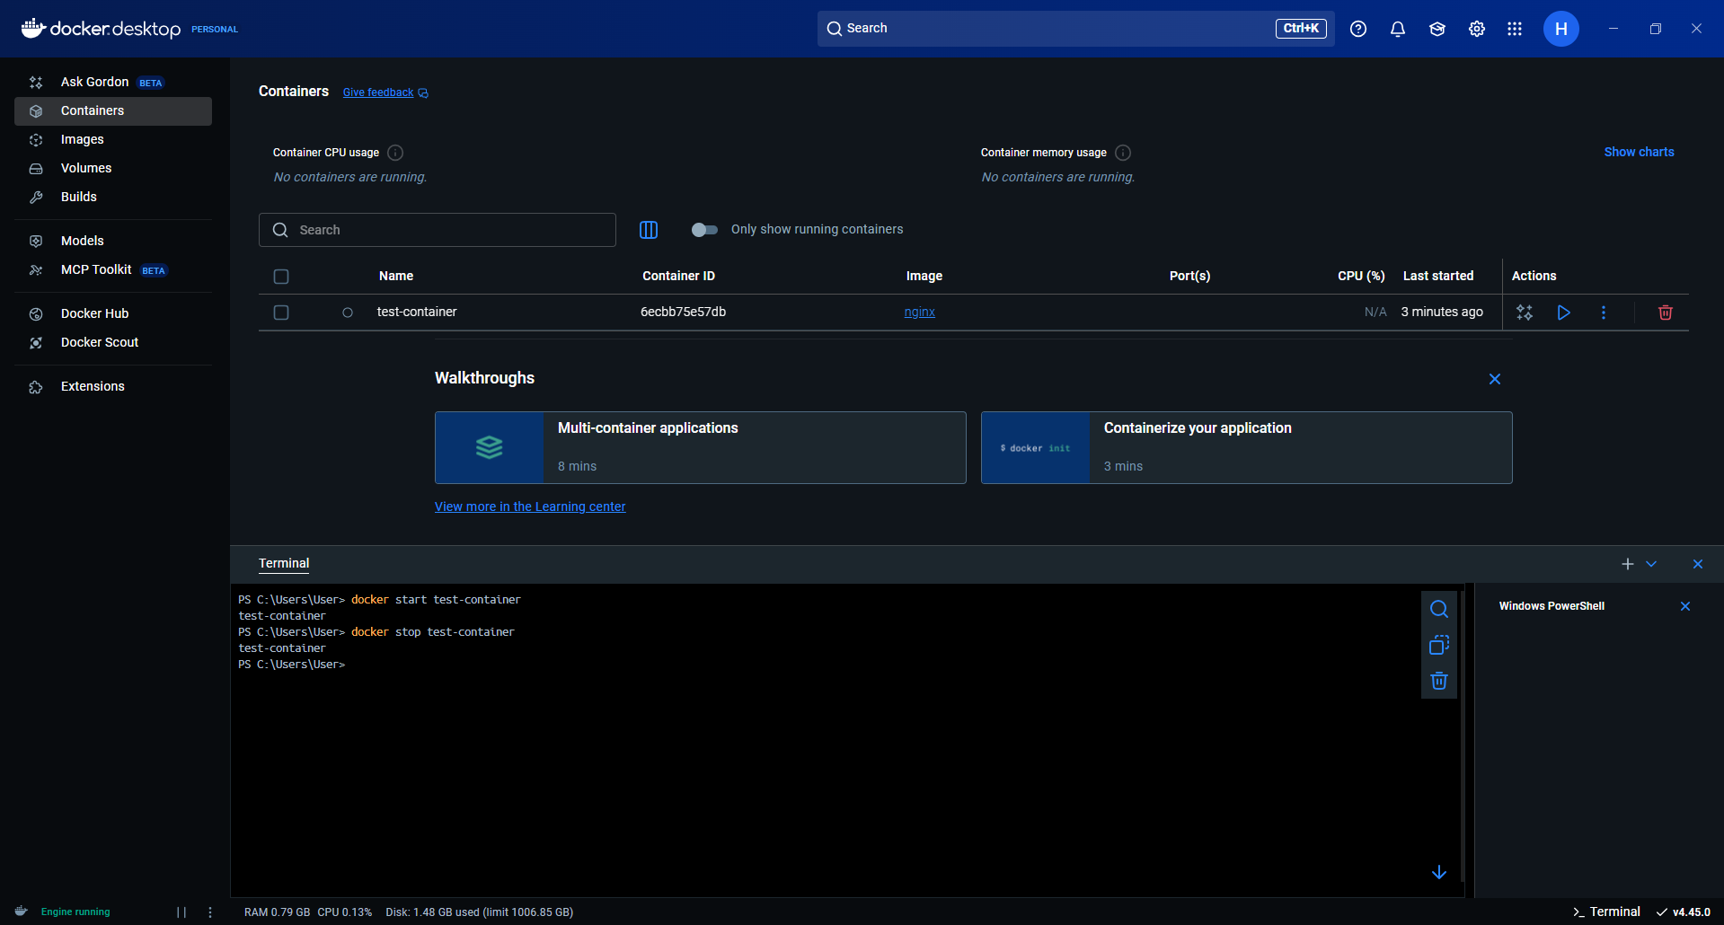

Remove a container

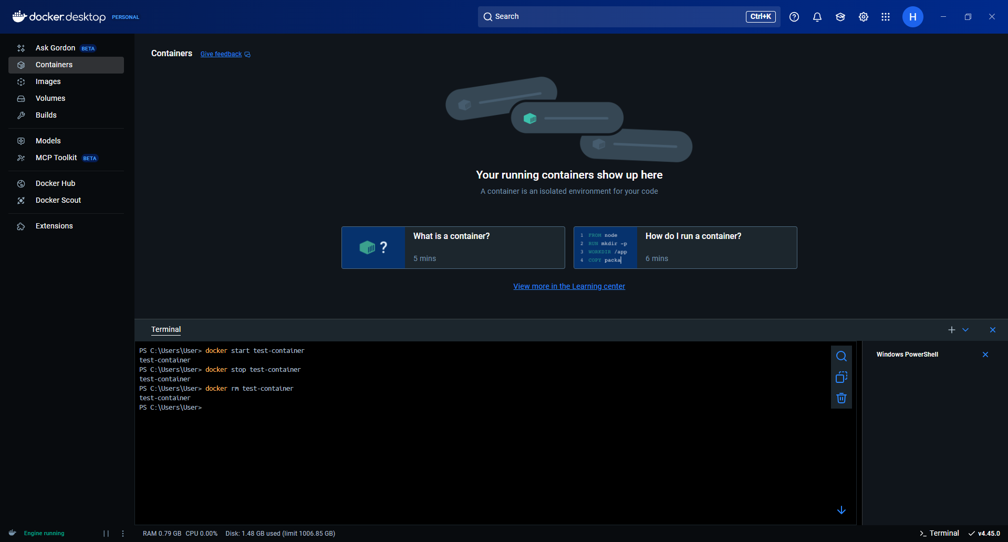

Pull an image

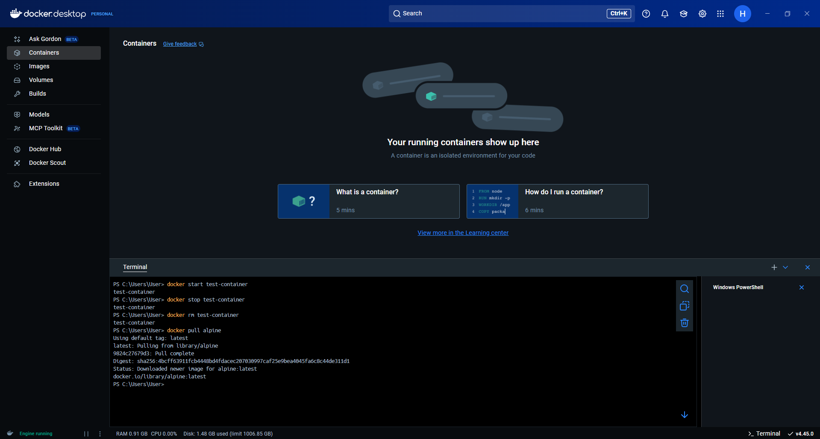

Remove an image with docker rmi

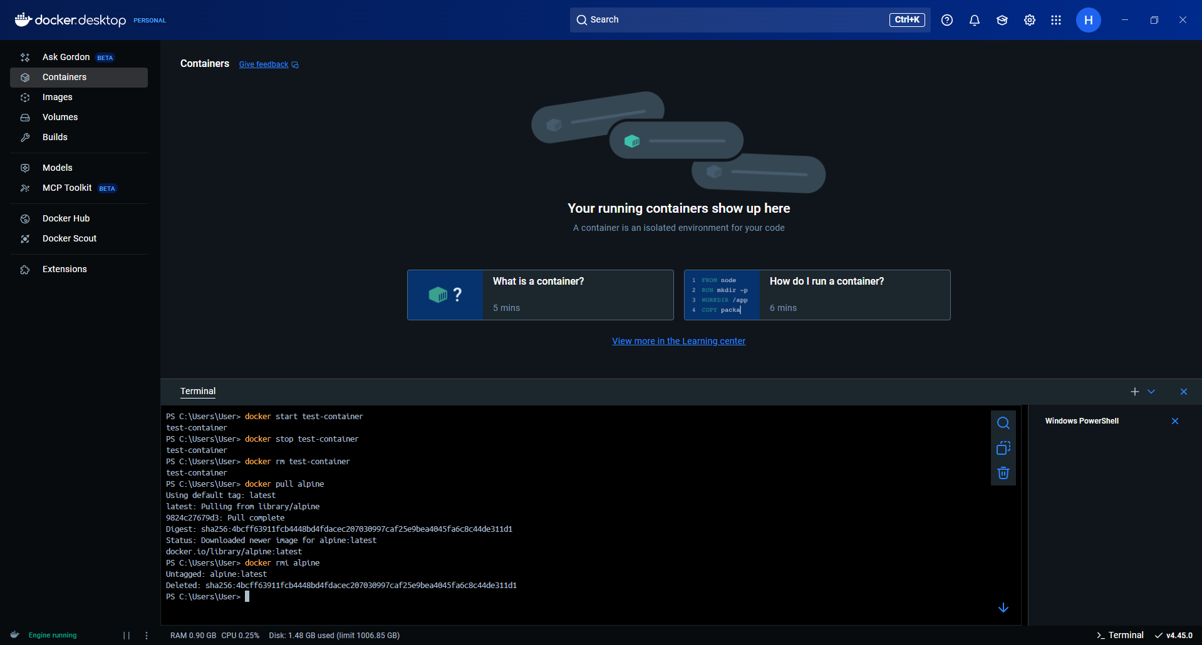

2. Docker Run

Run the hello-world container

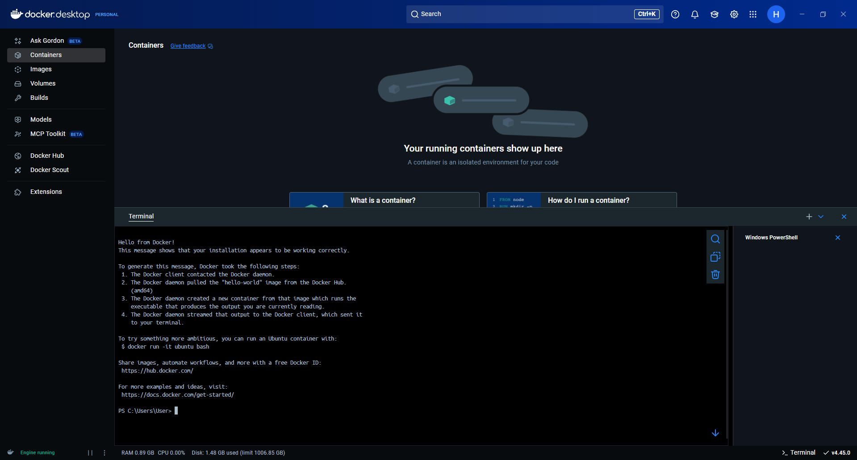

Run an Ubuntu container in interactive mode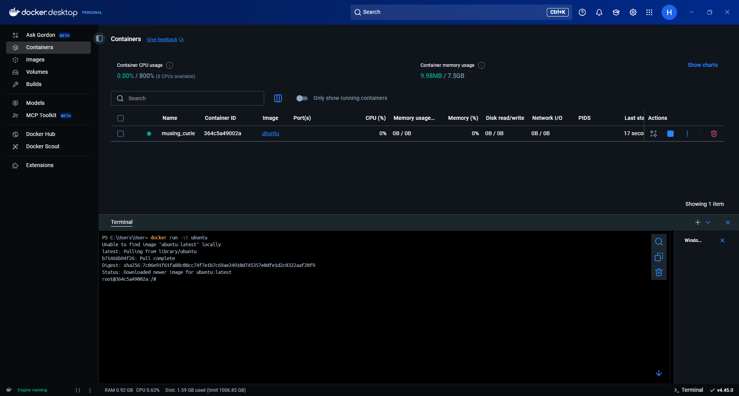

Exit Ubuntu container

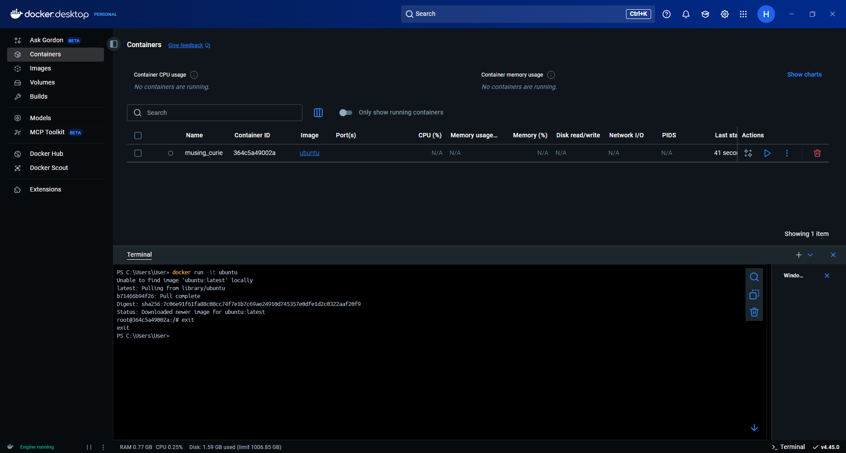

Run an Nginx container mapping host port 8080→ container port 80

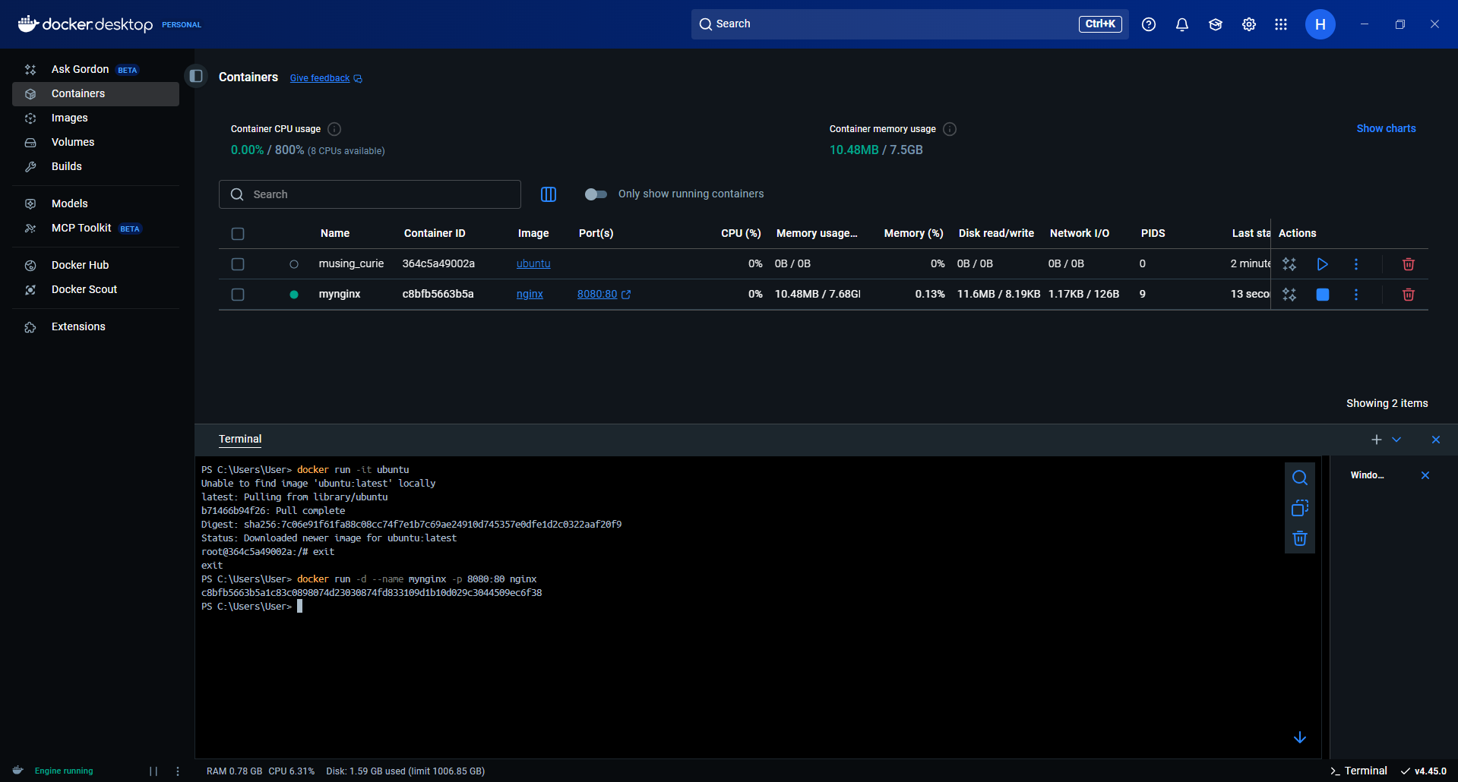

Access Nginx via browser at http://localhost:8080

.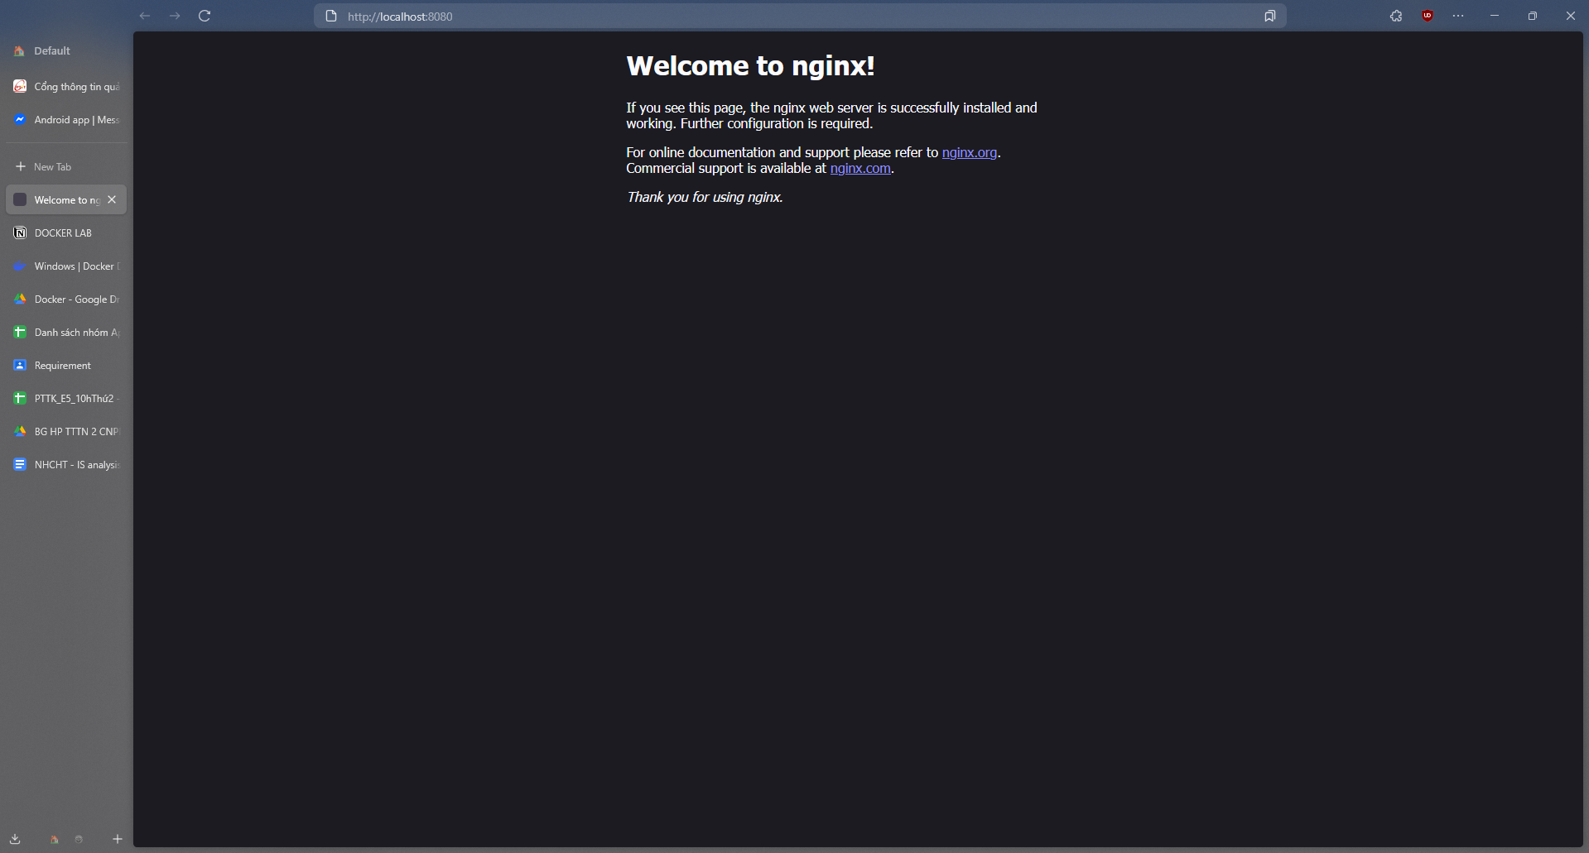

3. Docker Environment Variables

Run MySQL container with e MYSQL_ROOT_PASSWORD=my-secret-pw

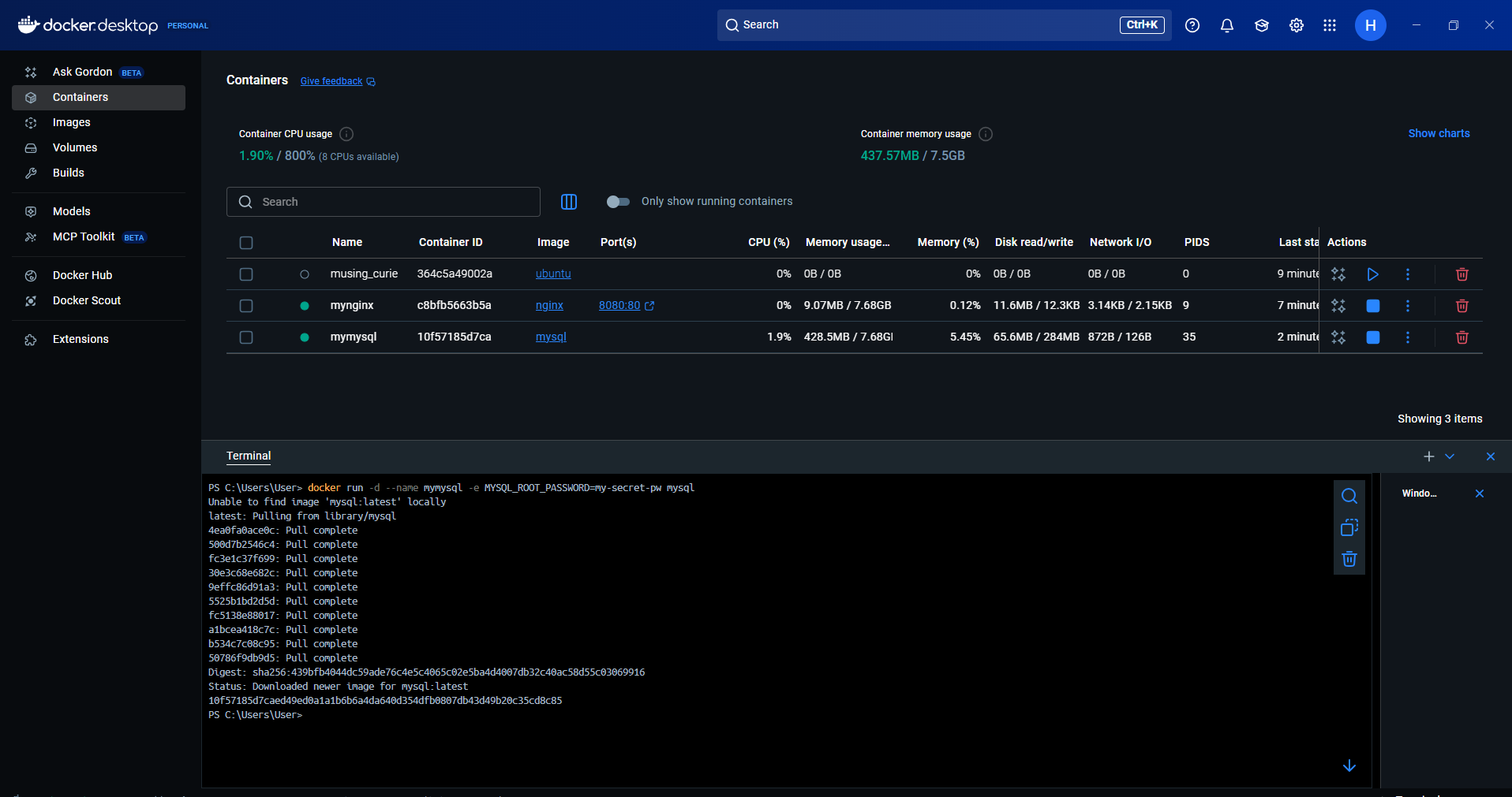

Verify variables with docker inspect <container_id>

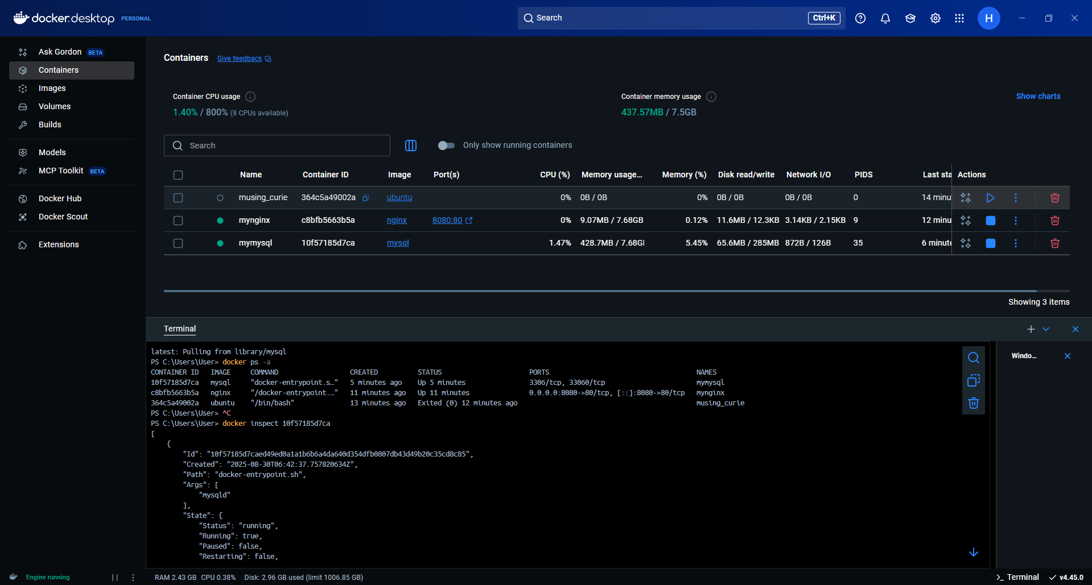

Run a custom container with user-defined env vars.

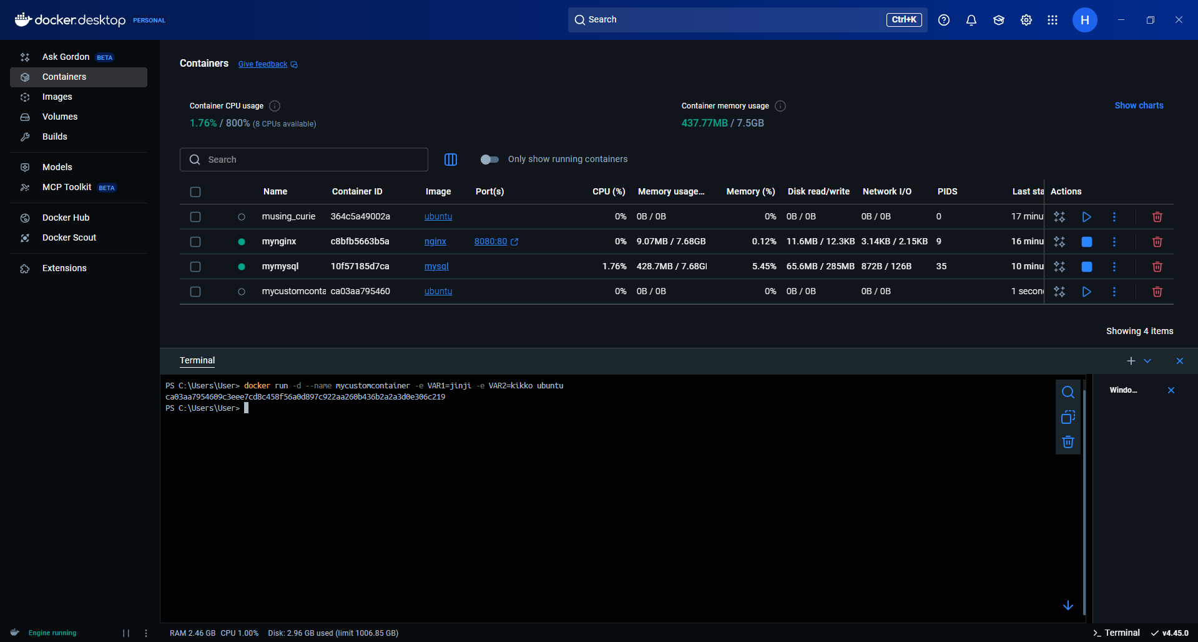

Verify variable

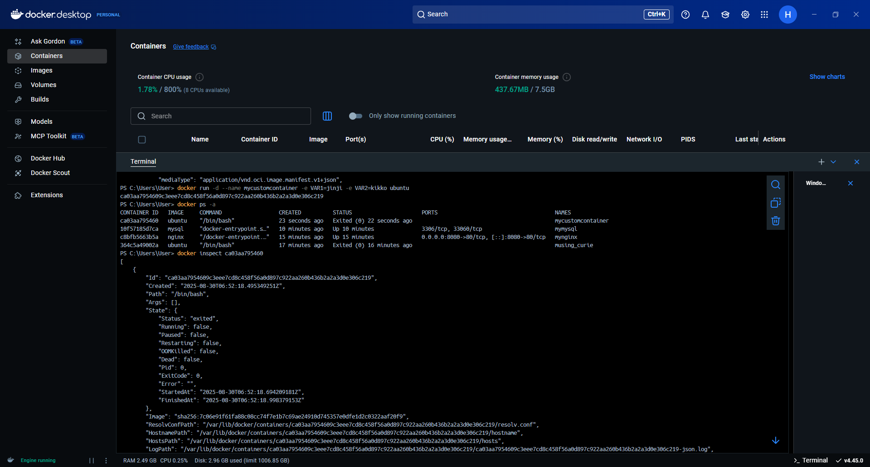

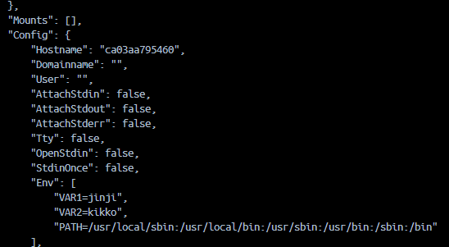

4. Docker Images

Create a Dockerfile in the root of your app repo (React app).

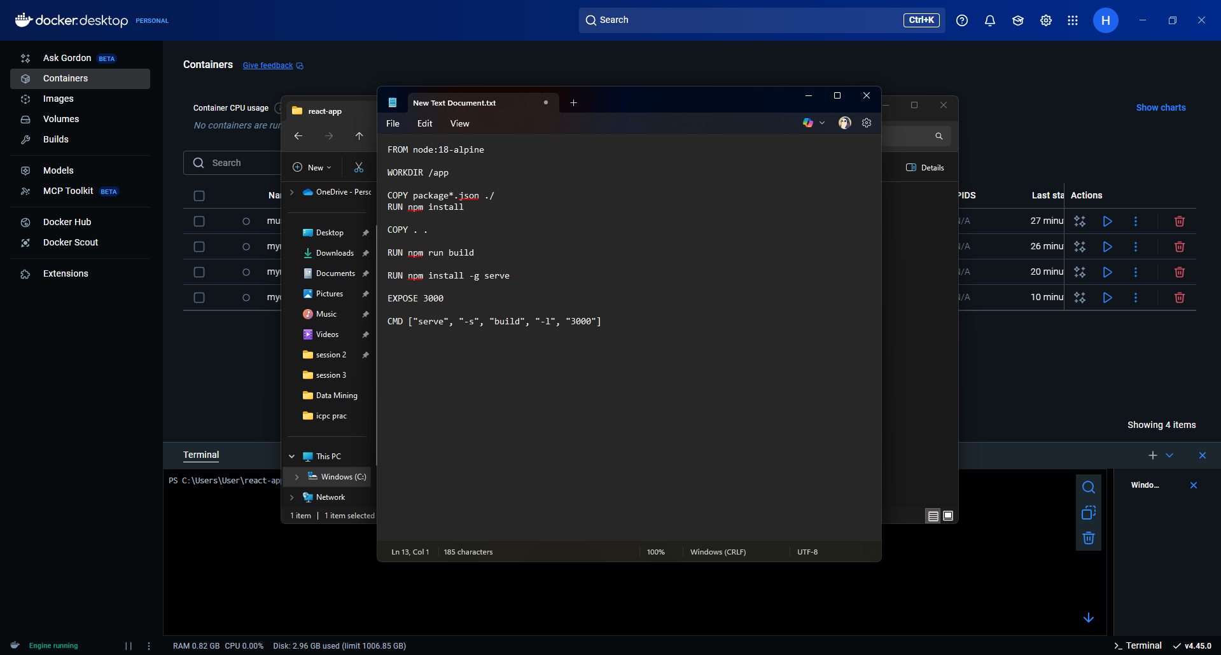

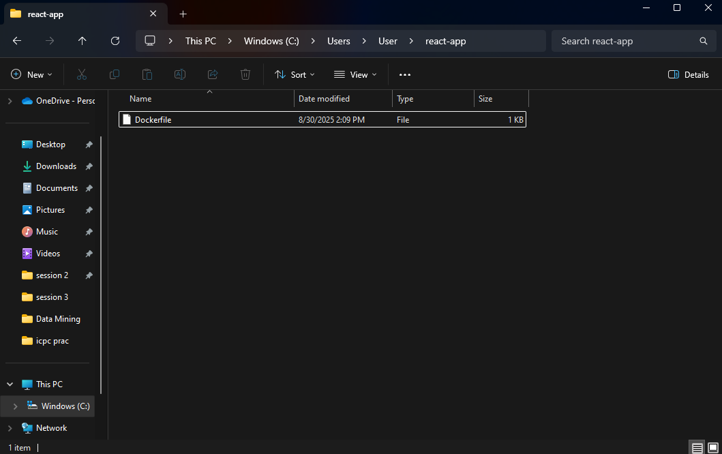

Create react app

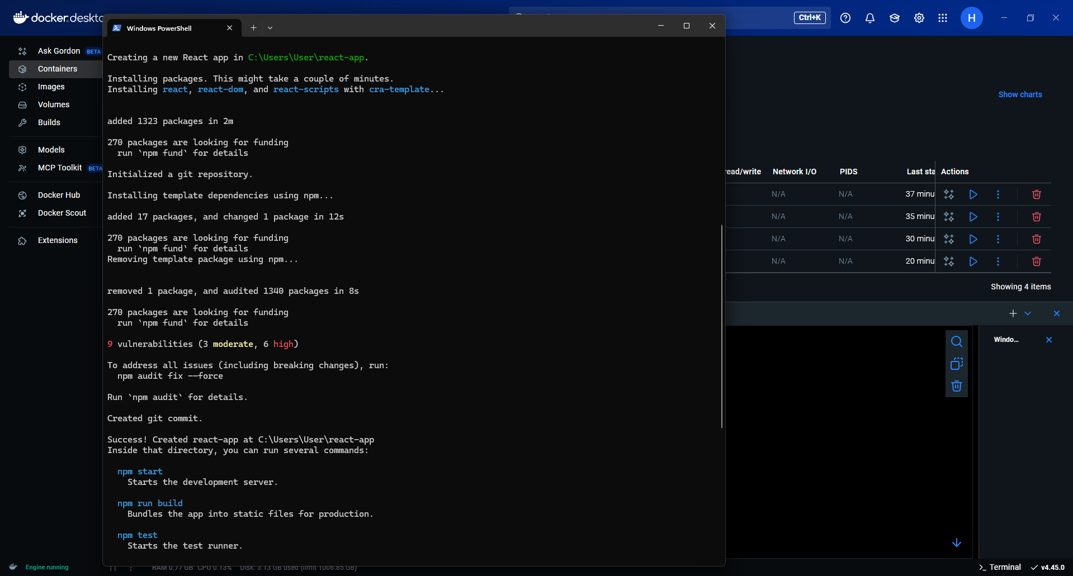

Build docker app with docker build -t myreactapp .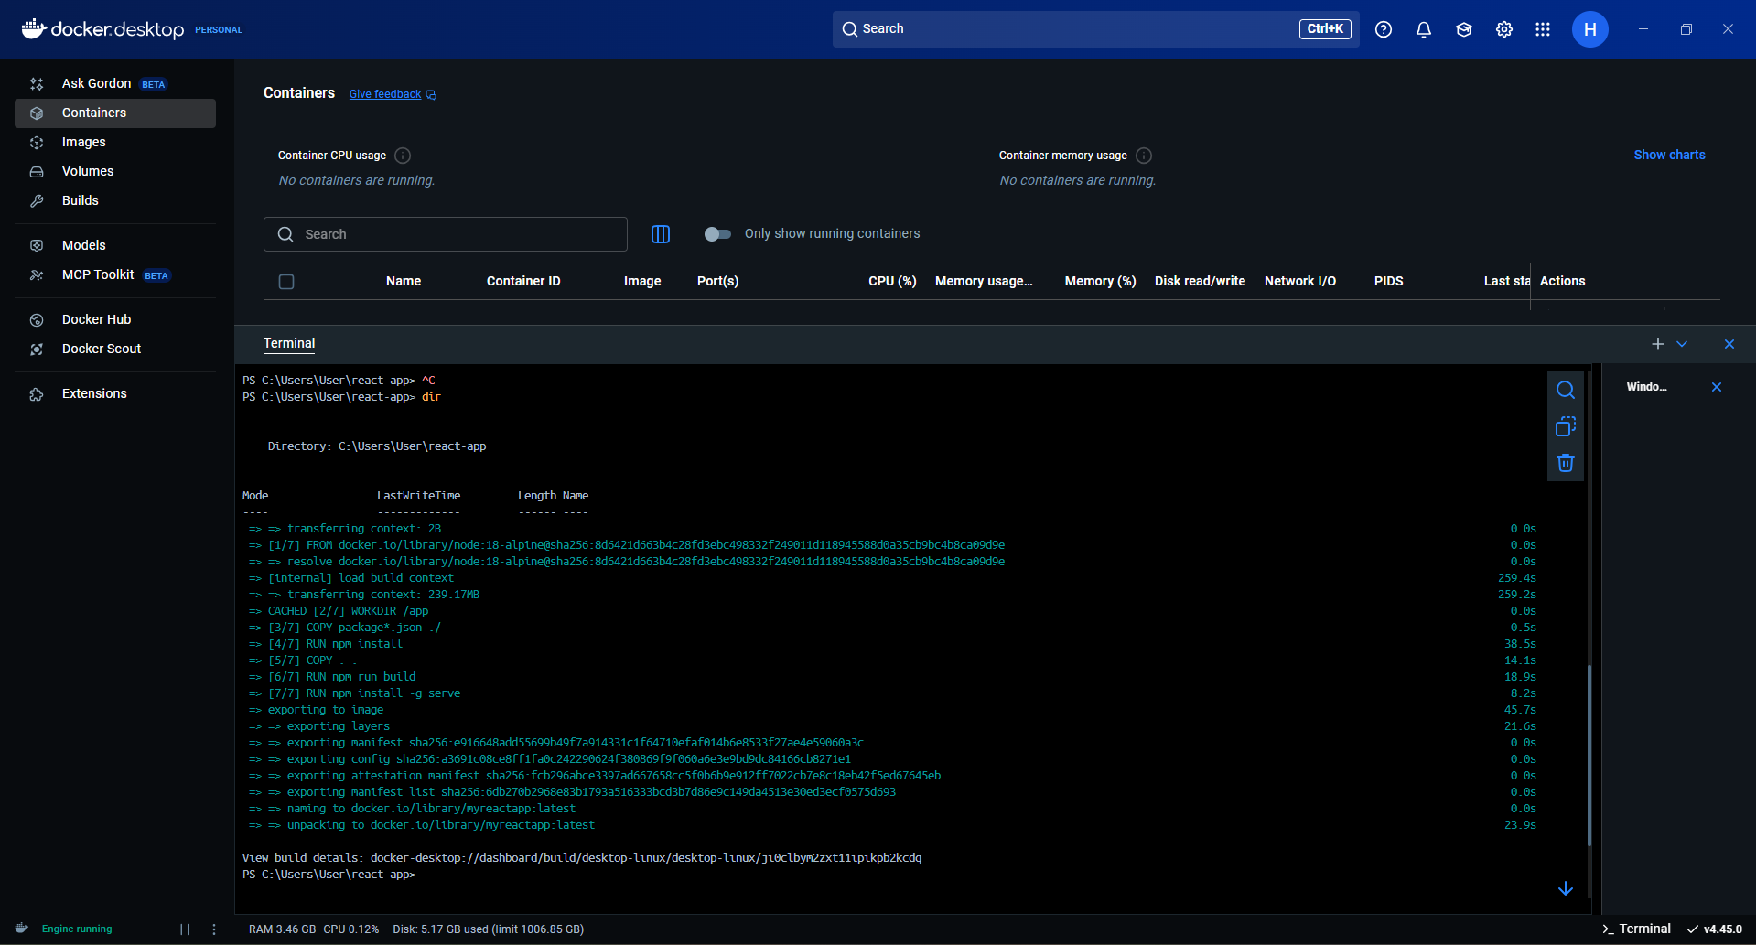

Run container

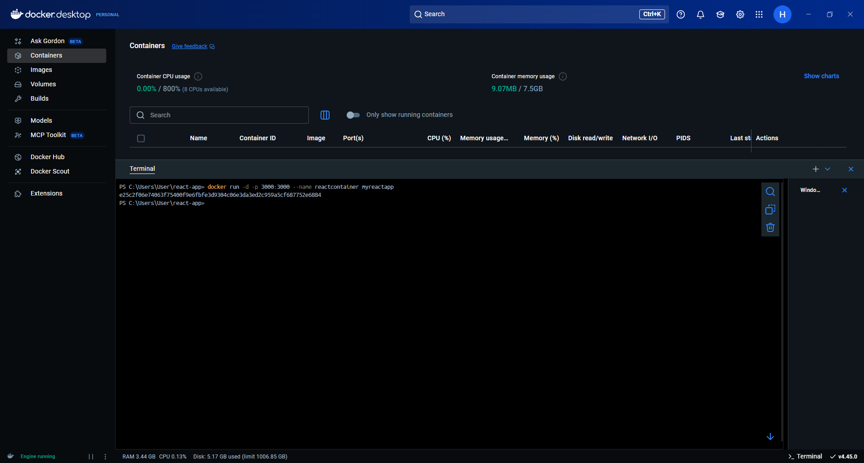

Test on browser

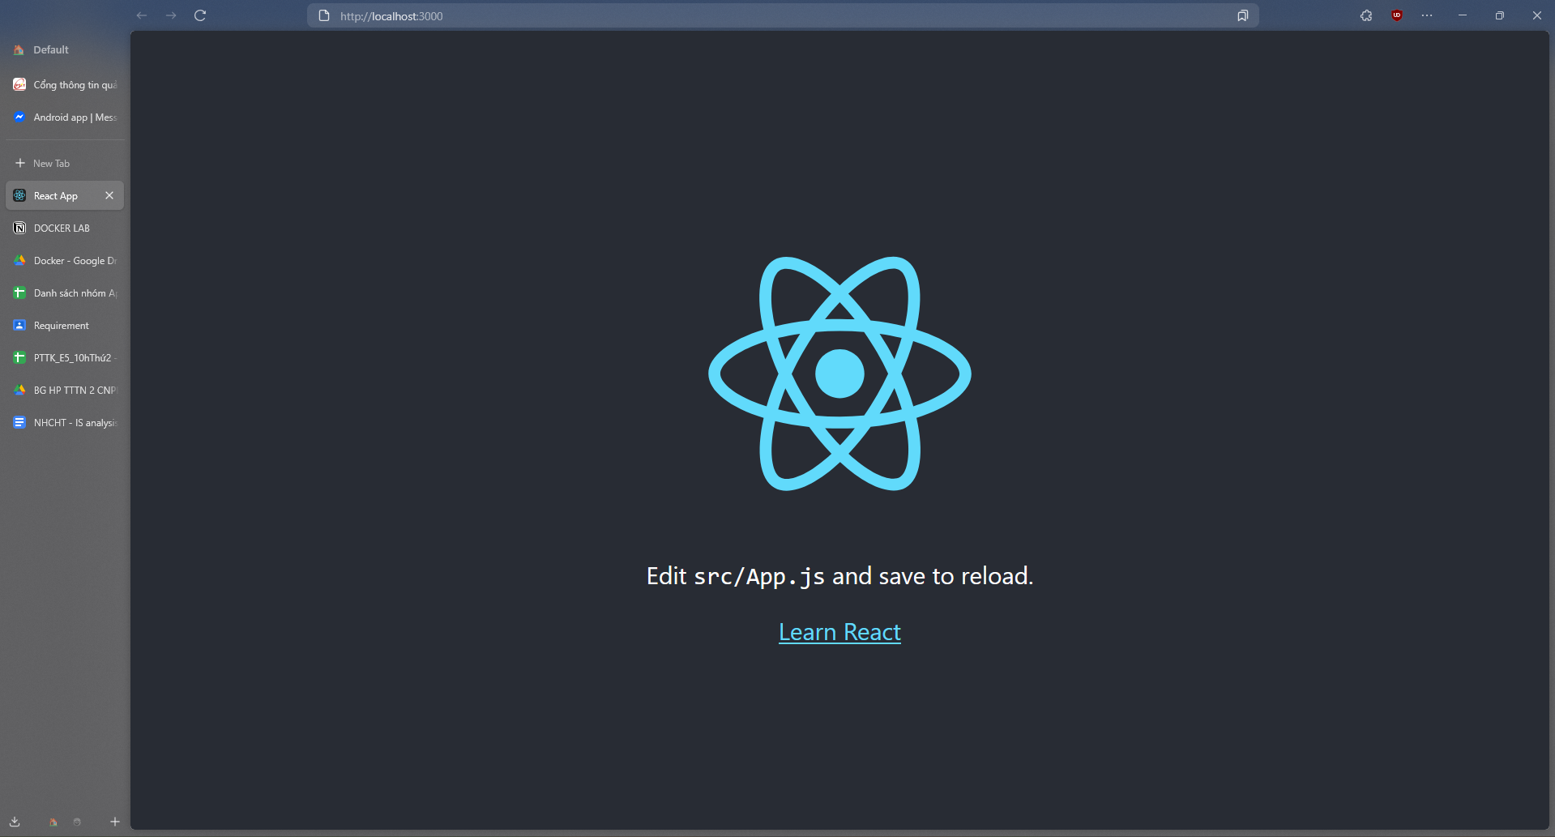

5. Docker Registry (GitLab Container Registry)

Enable GitLab Container Registry for your project.

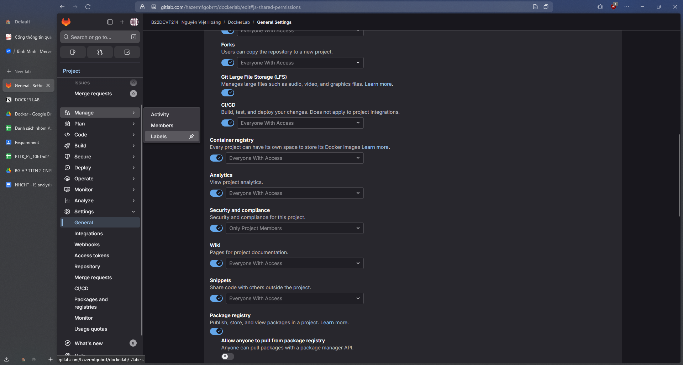

Login GitLab

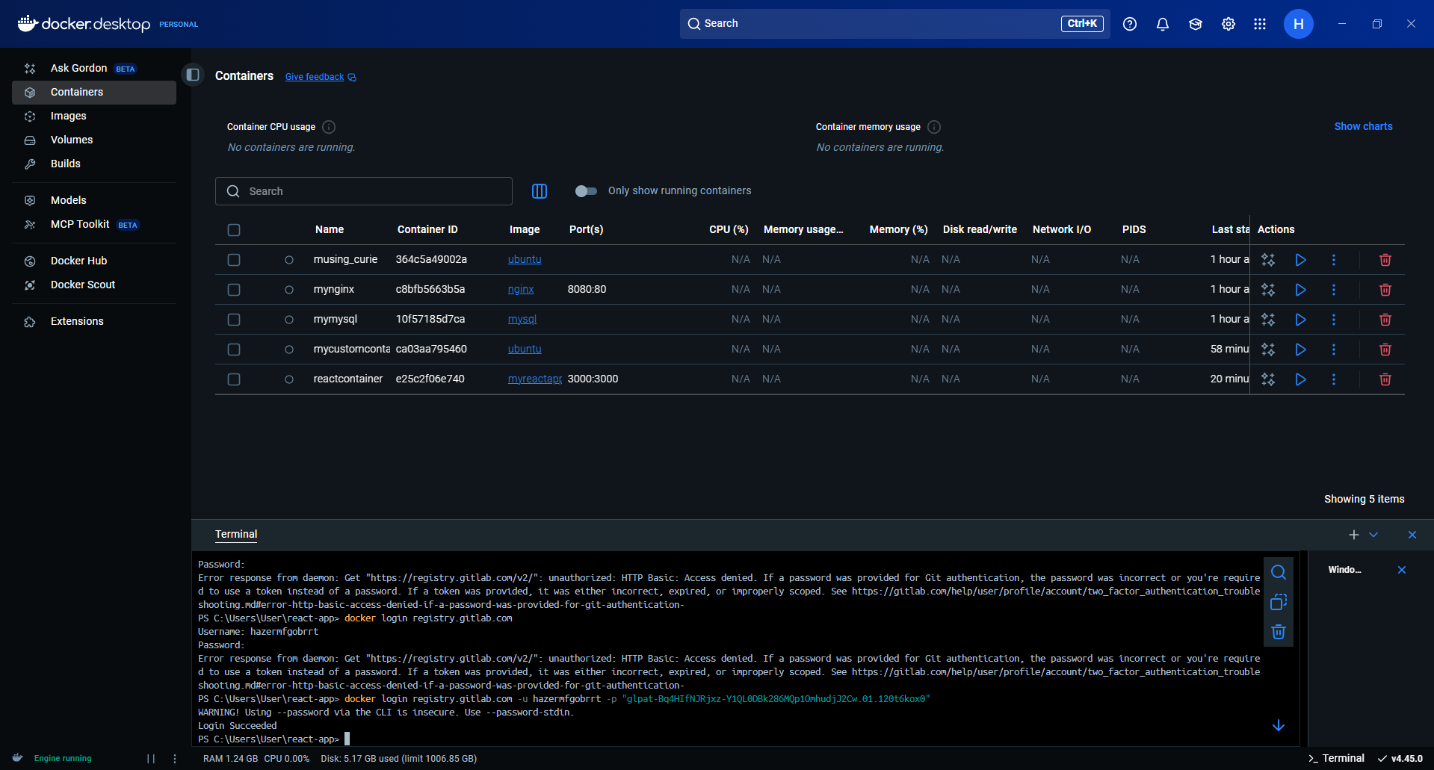

Tag local image

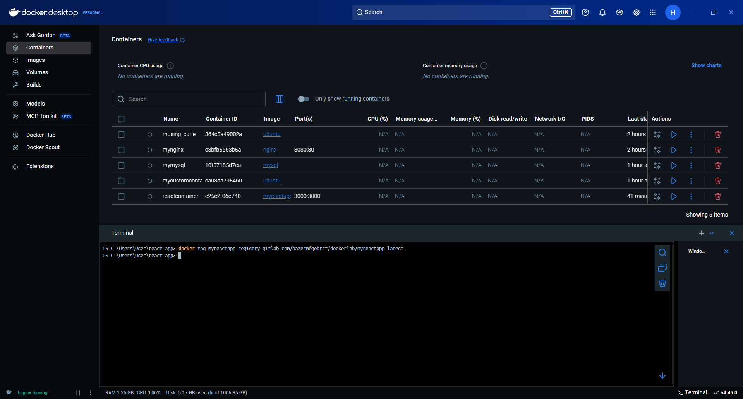

Push the image

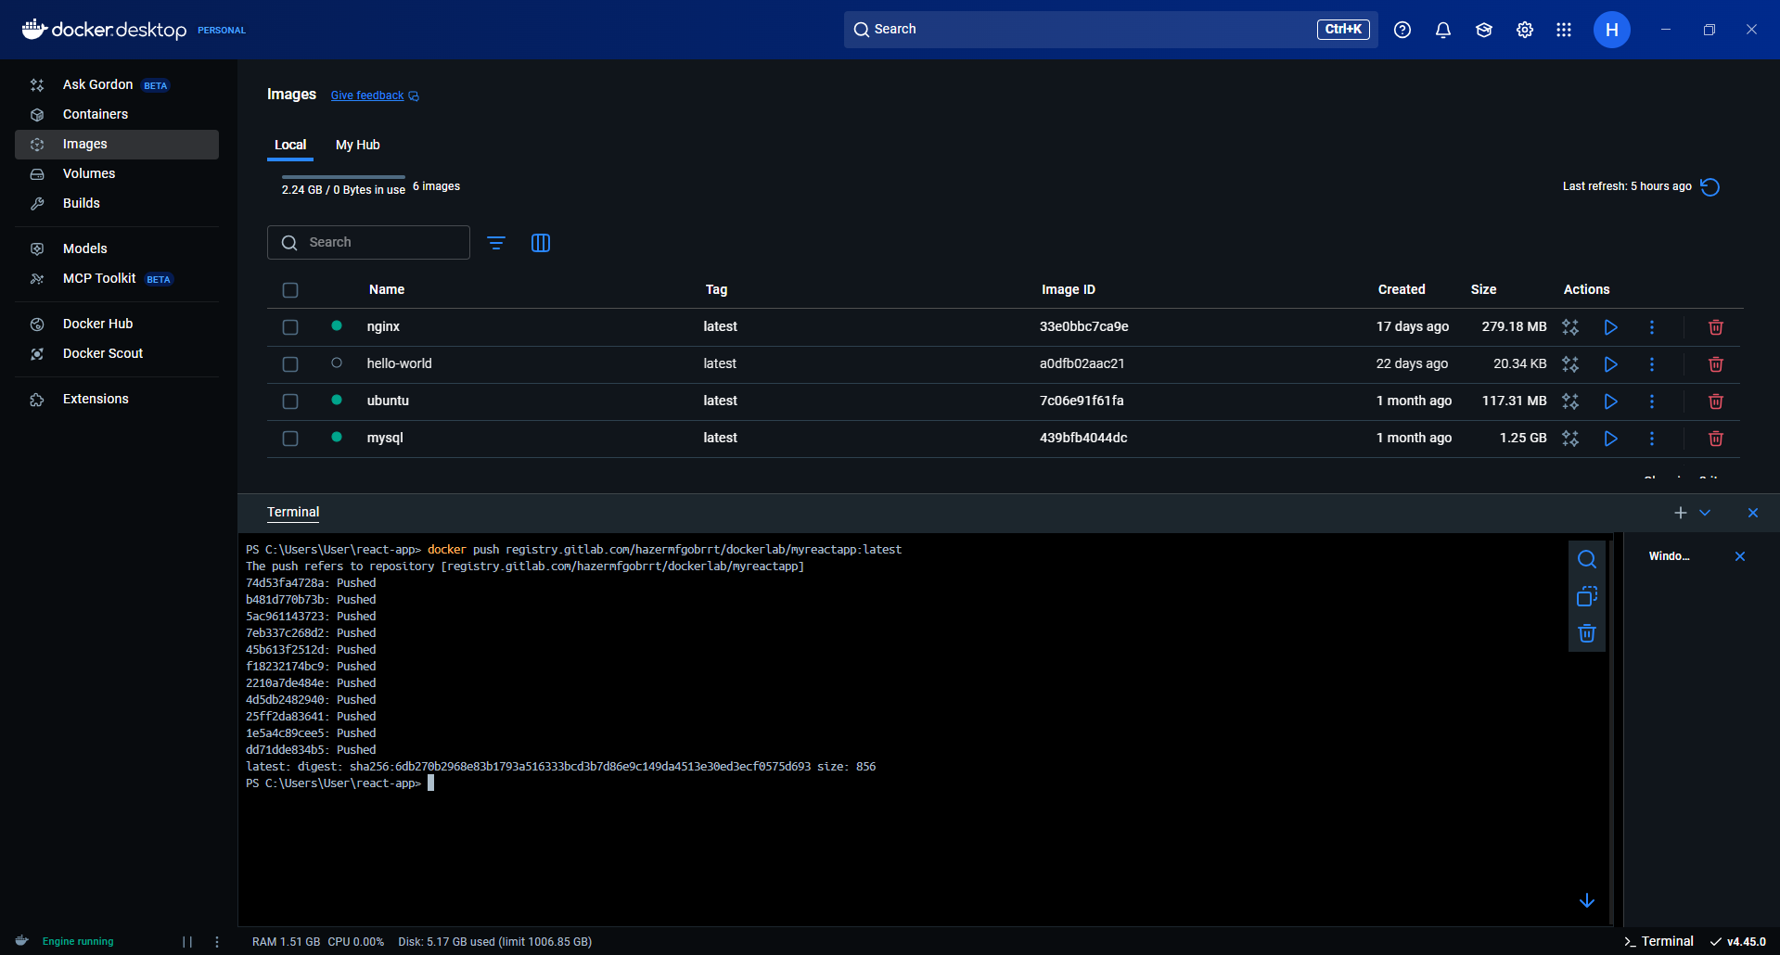

Remove local image

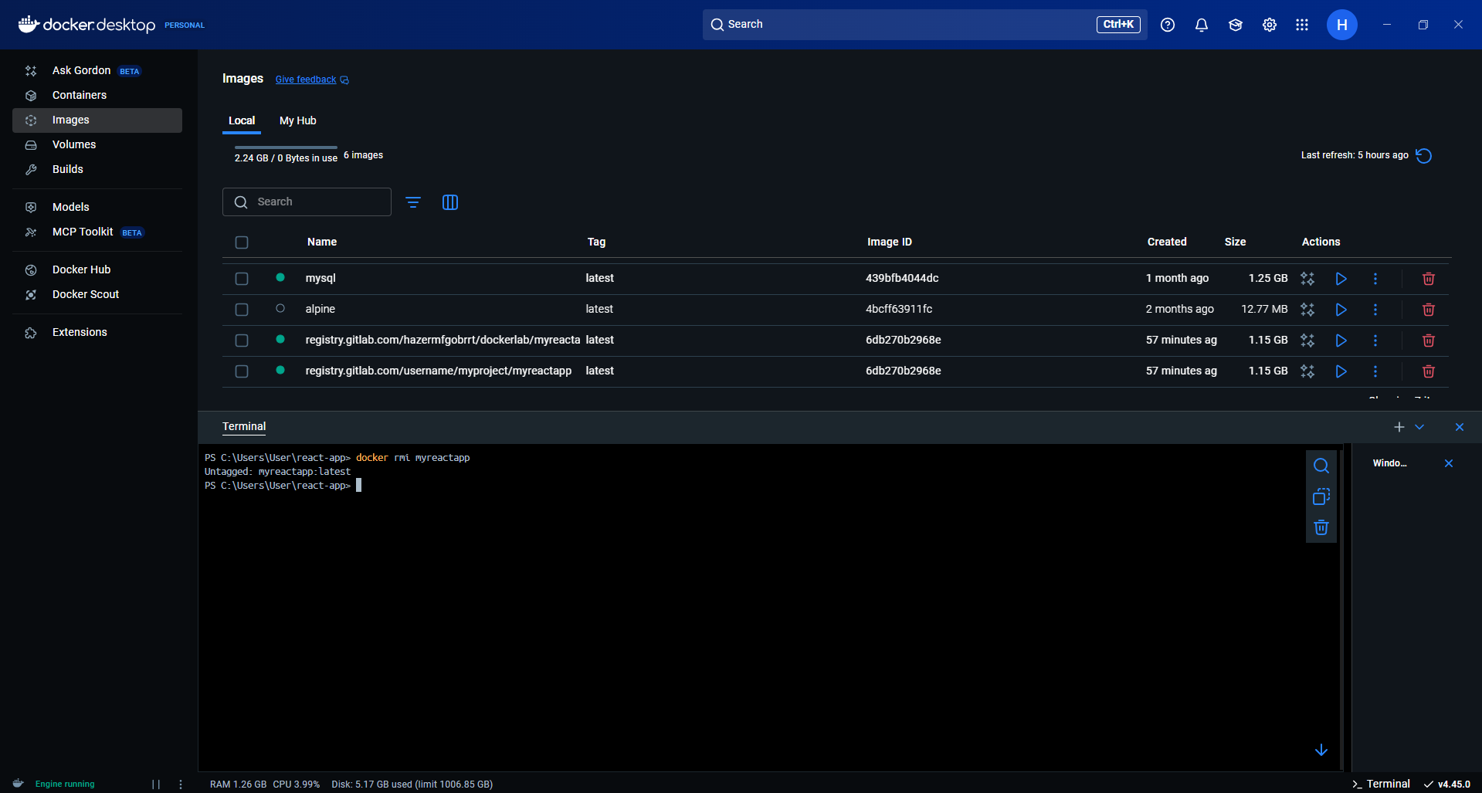

Pull the image back

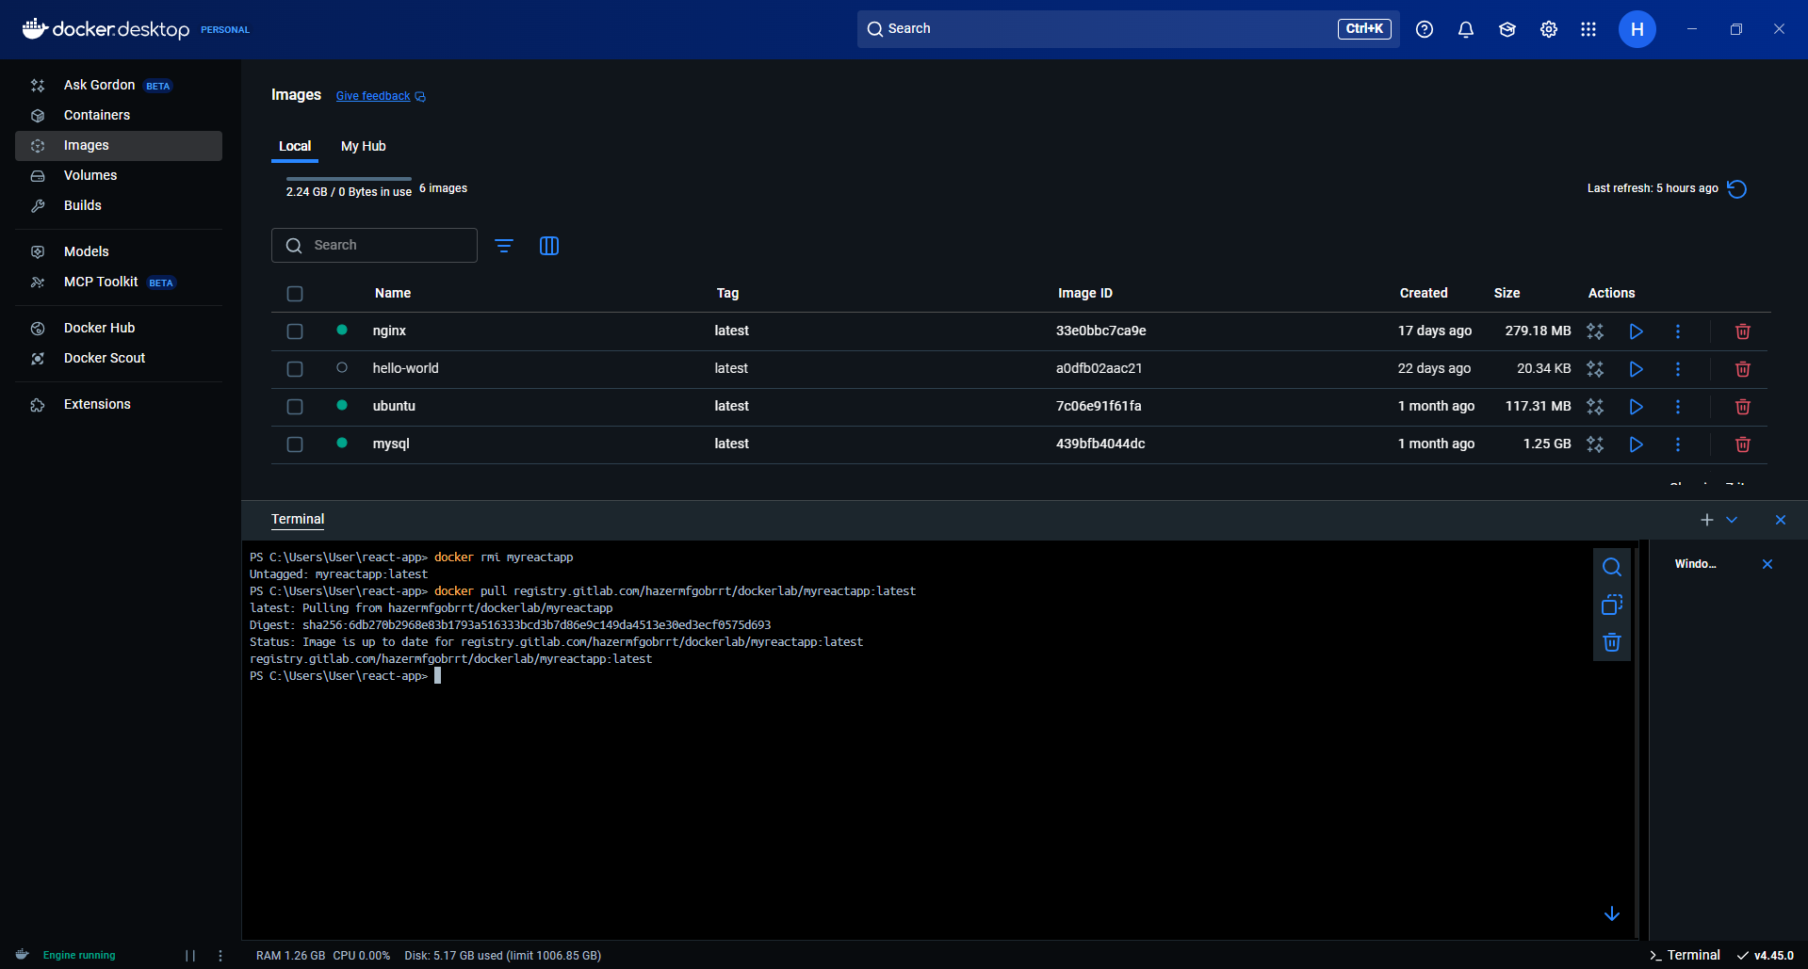

Run container

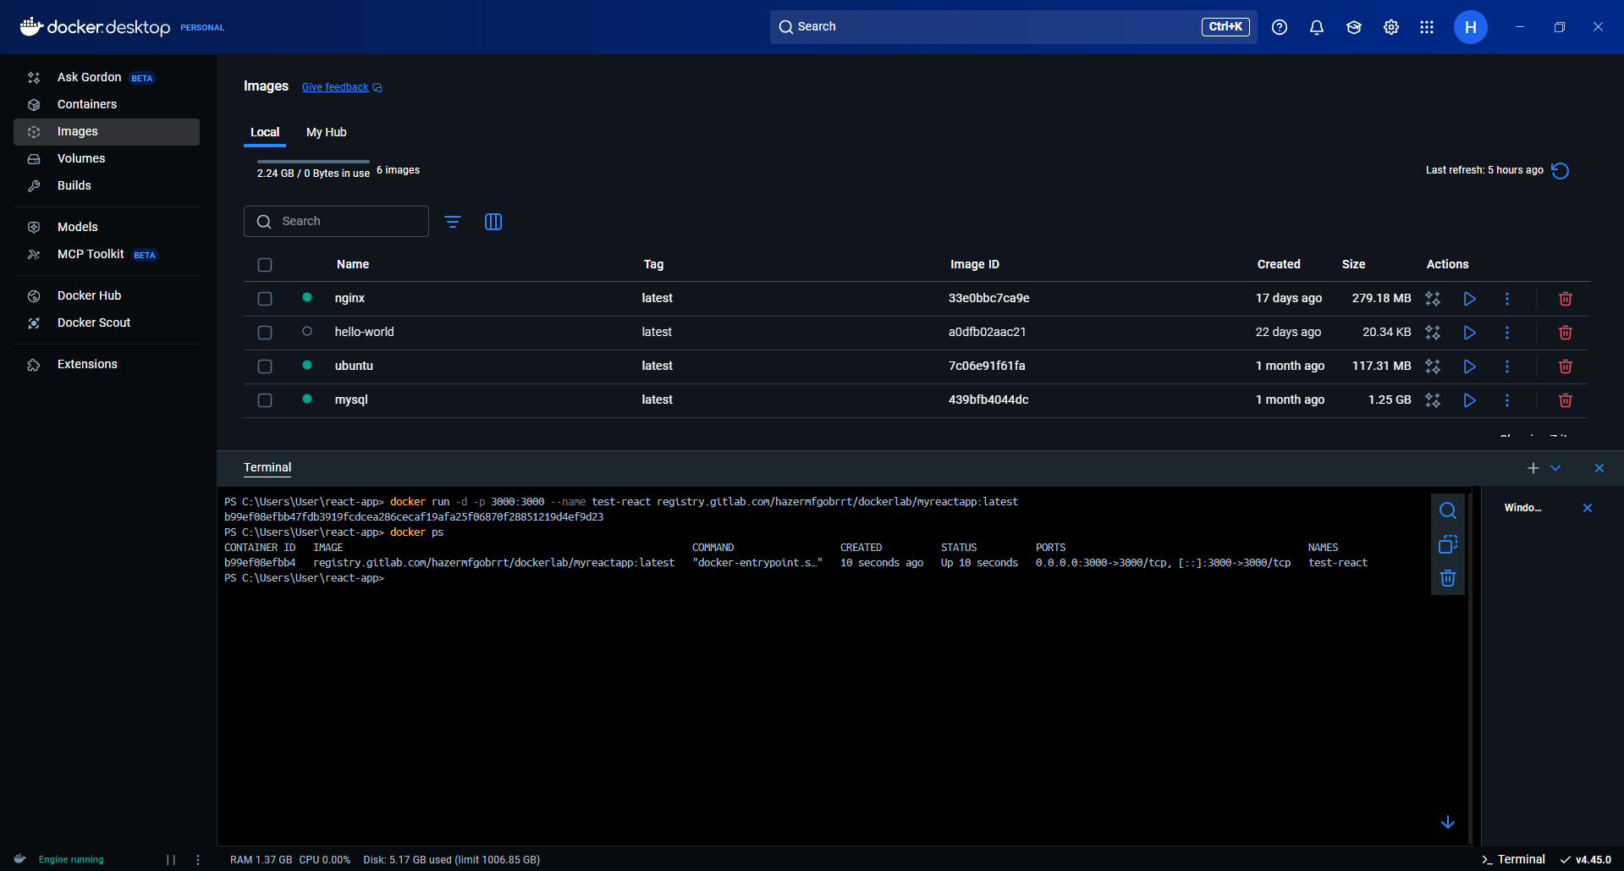

6. Docker Compose (Part 1 – Basics)

Create docker-compose.yml with services

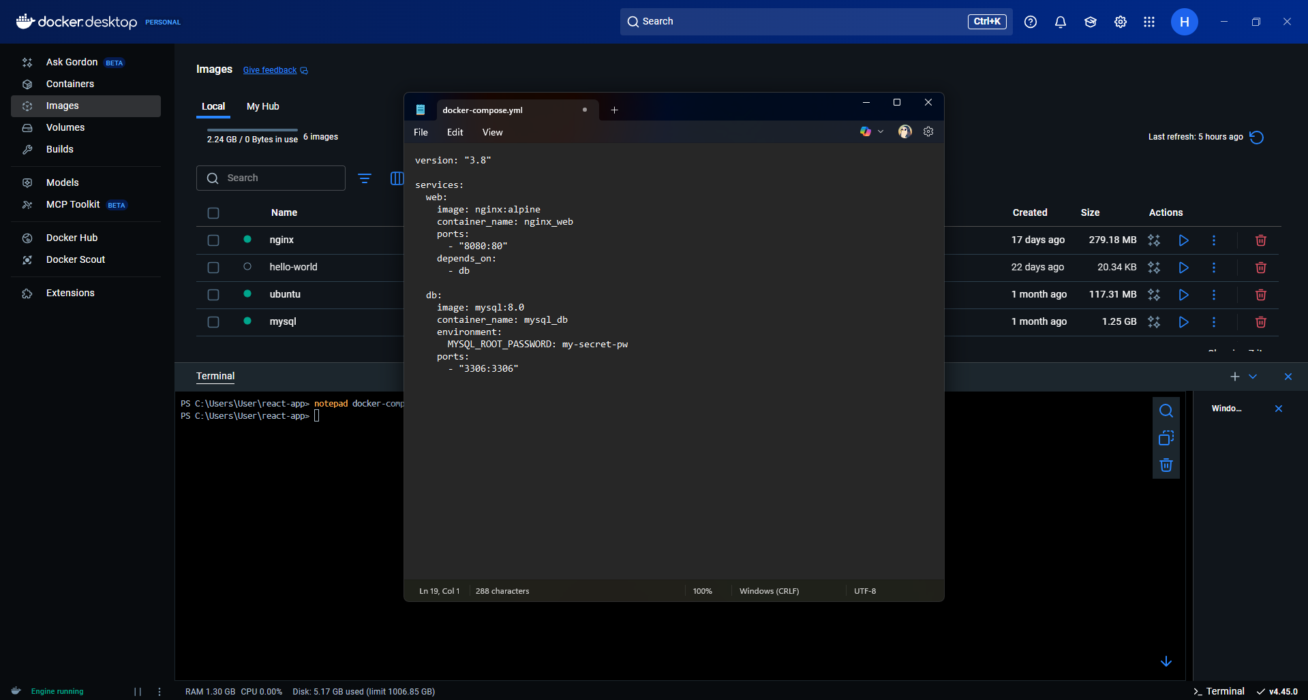

Run docker compose up

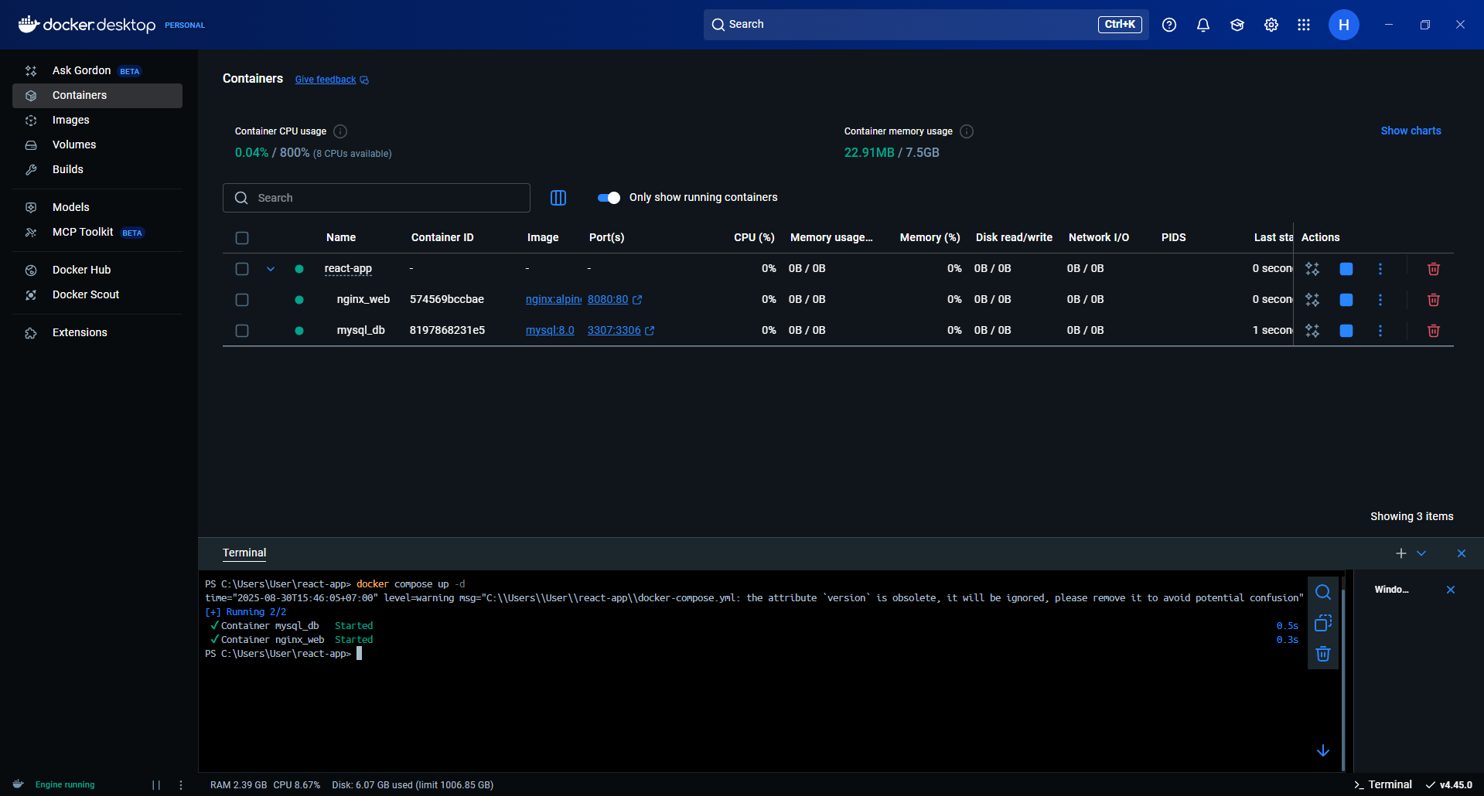

Verify both containers are running with docker ps

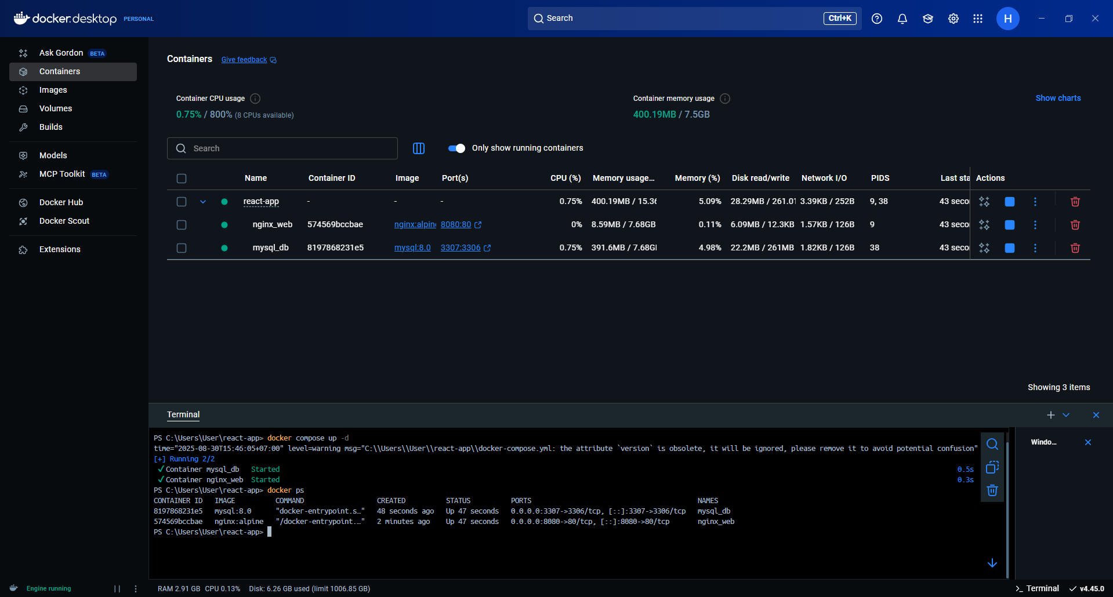

7. Docker Storage

Run MySQL with a named volume

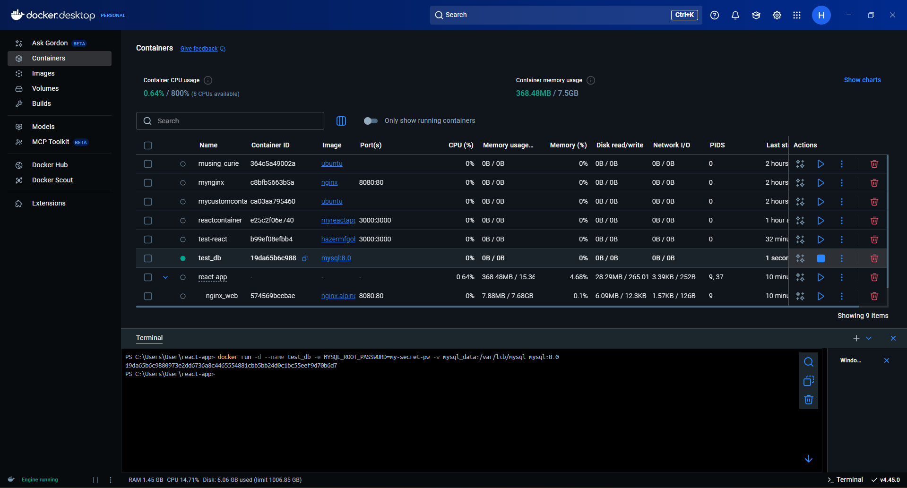

Create a table

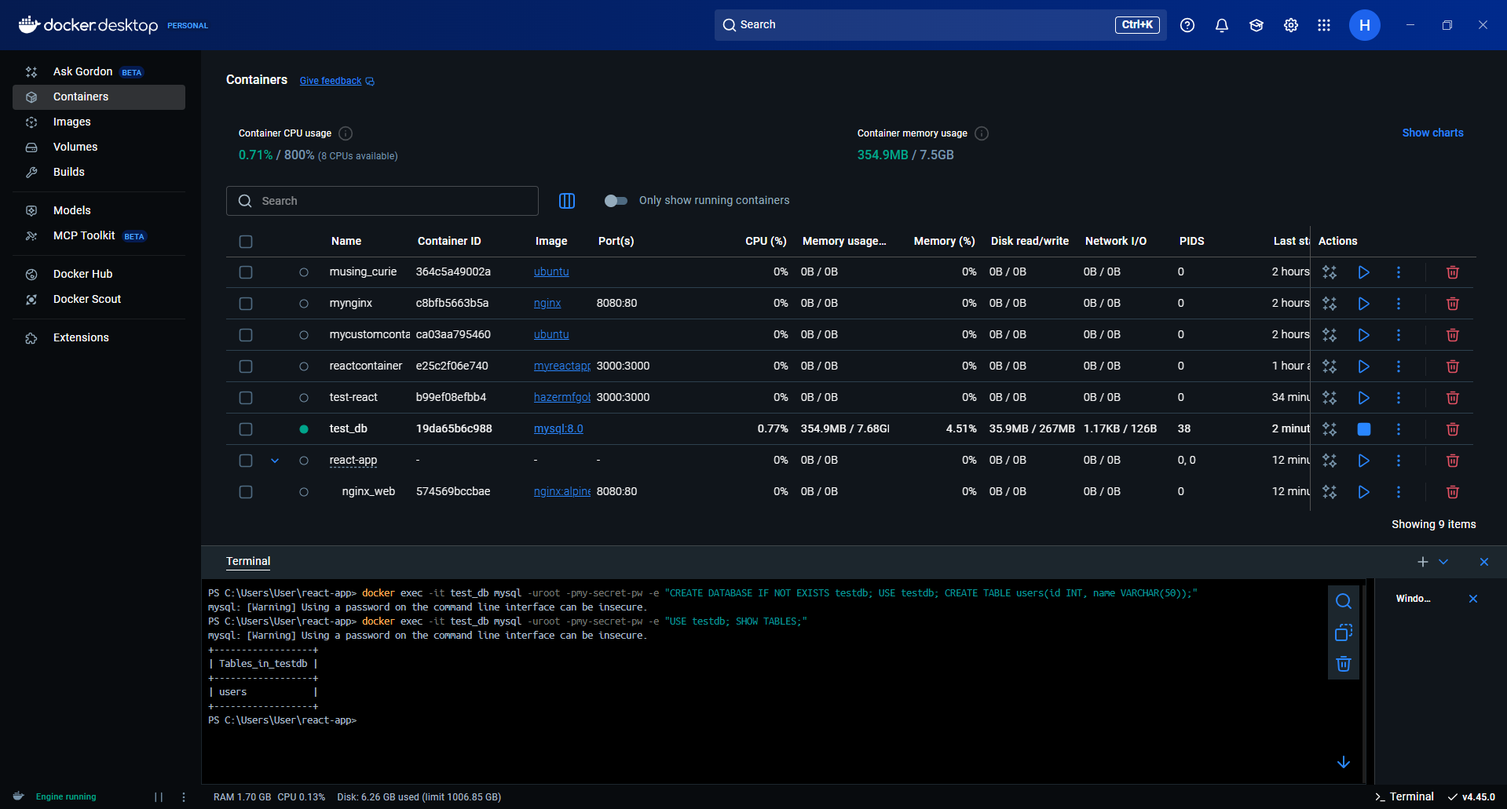

Stop and remove the container

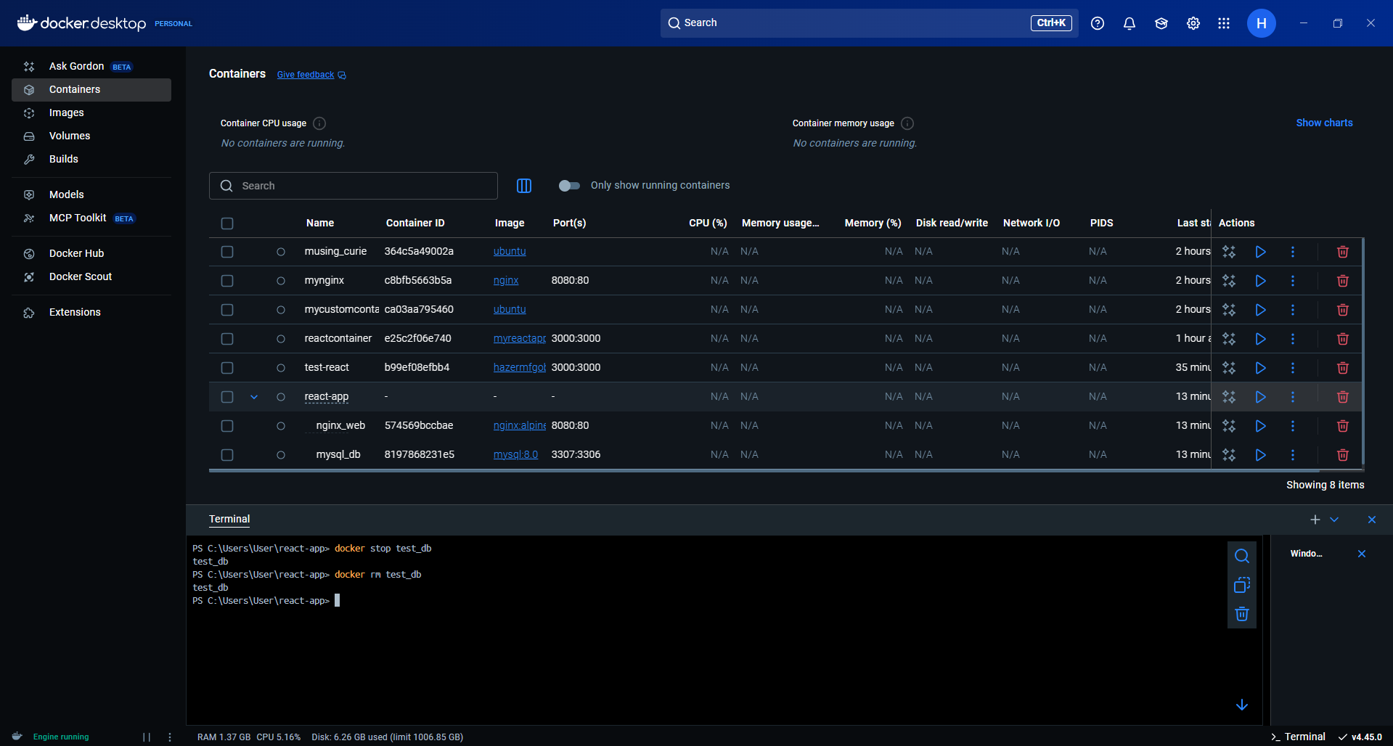

Start a new MySQL container using the same volume

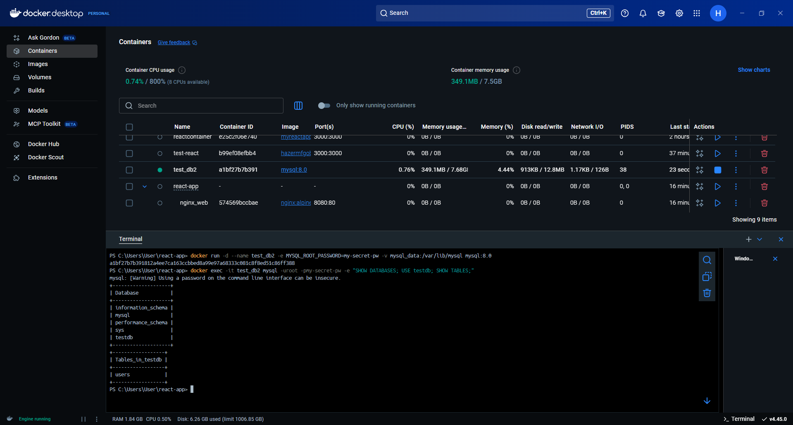

8. Docker Network

List networks with docker network ls

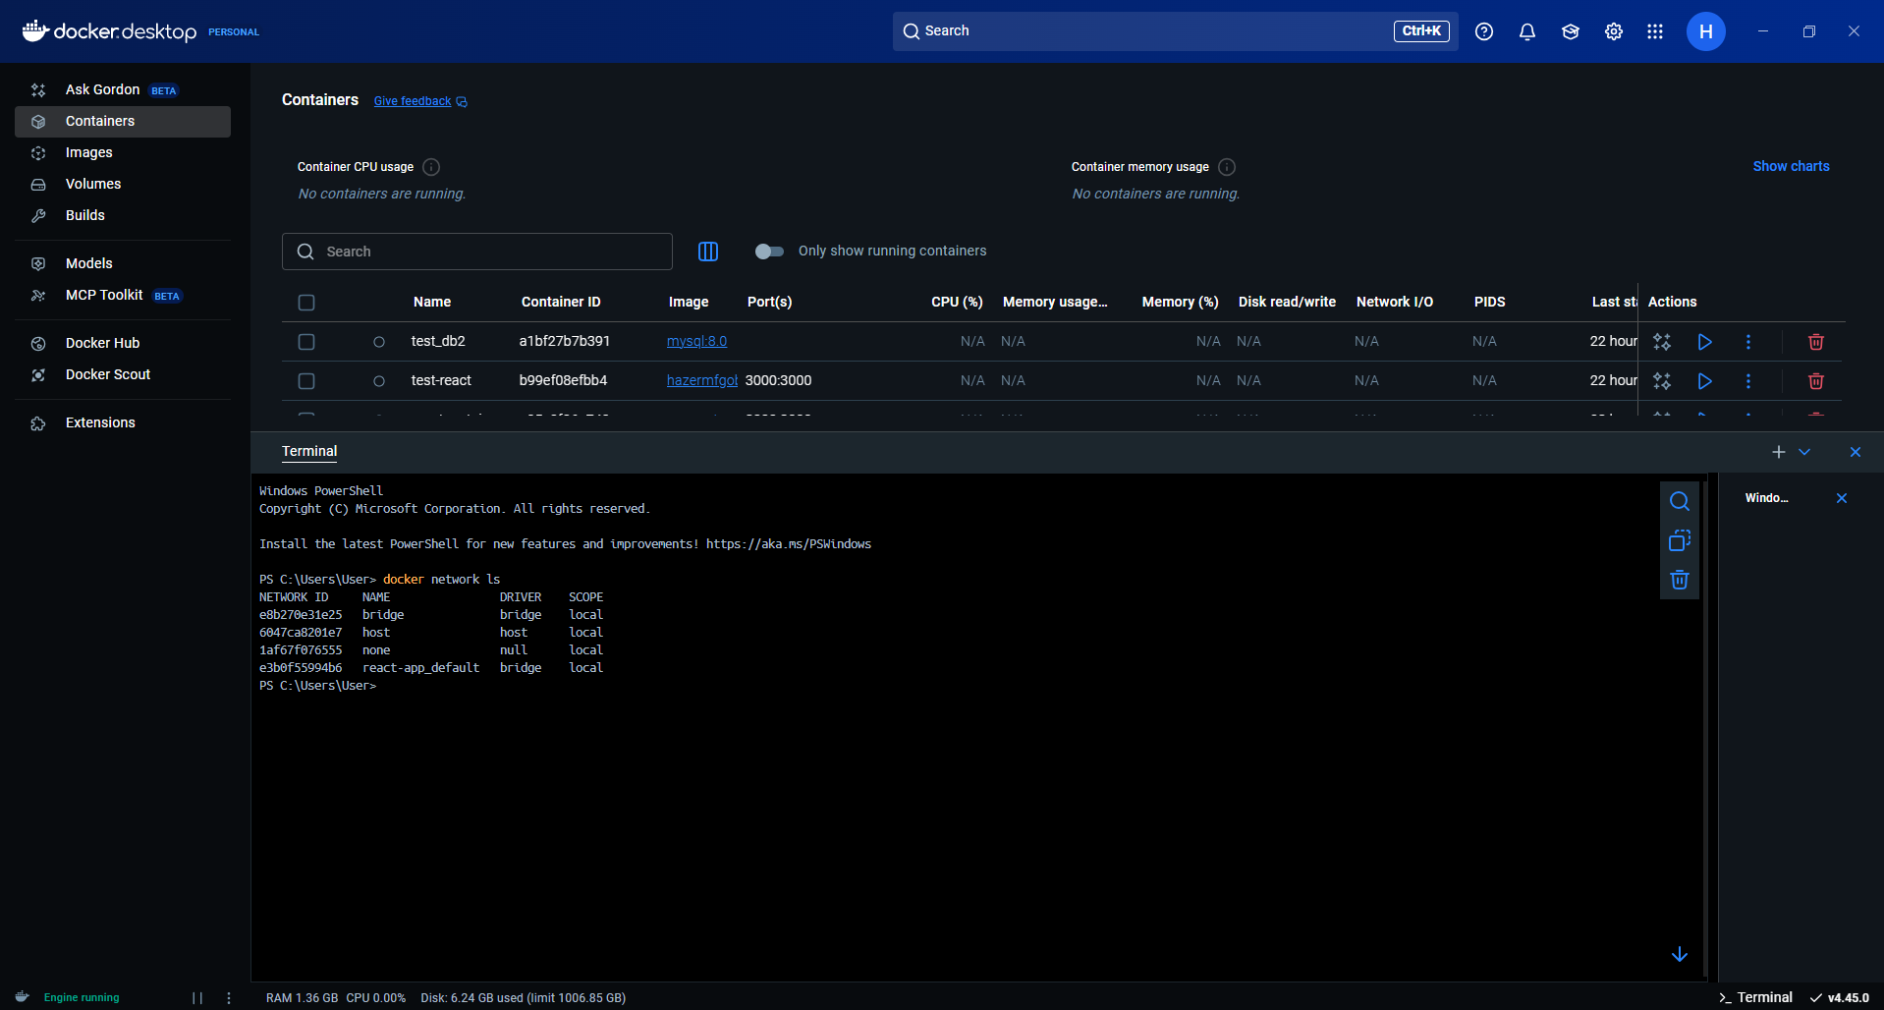

Create a custom bridge network

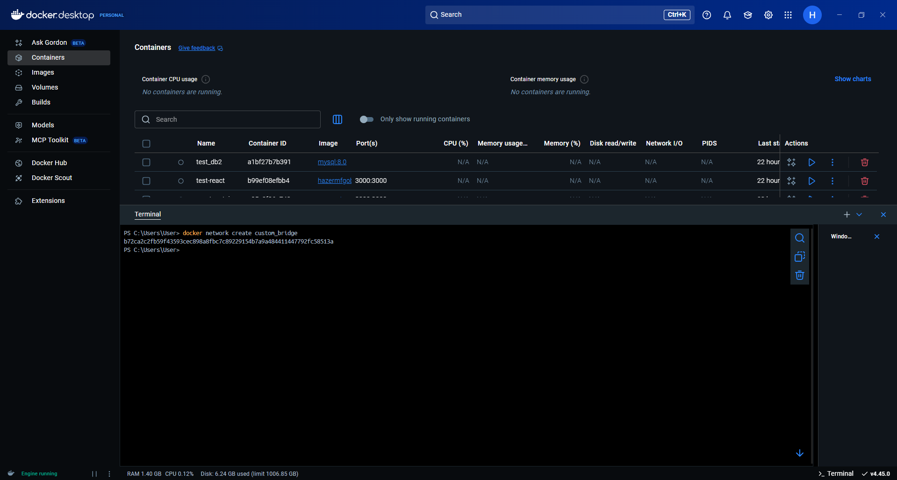

Run two containers in the same network and ping each other

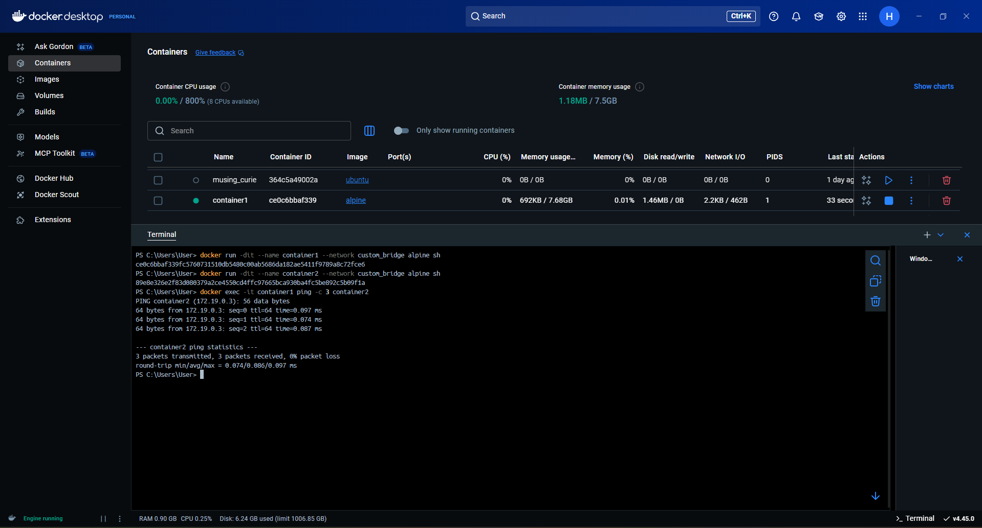

Run containers in different networks and test communication

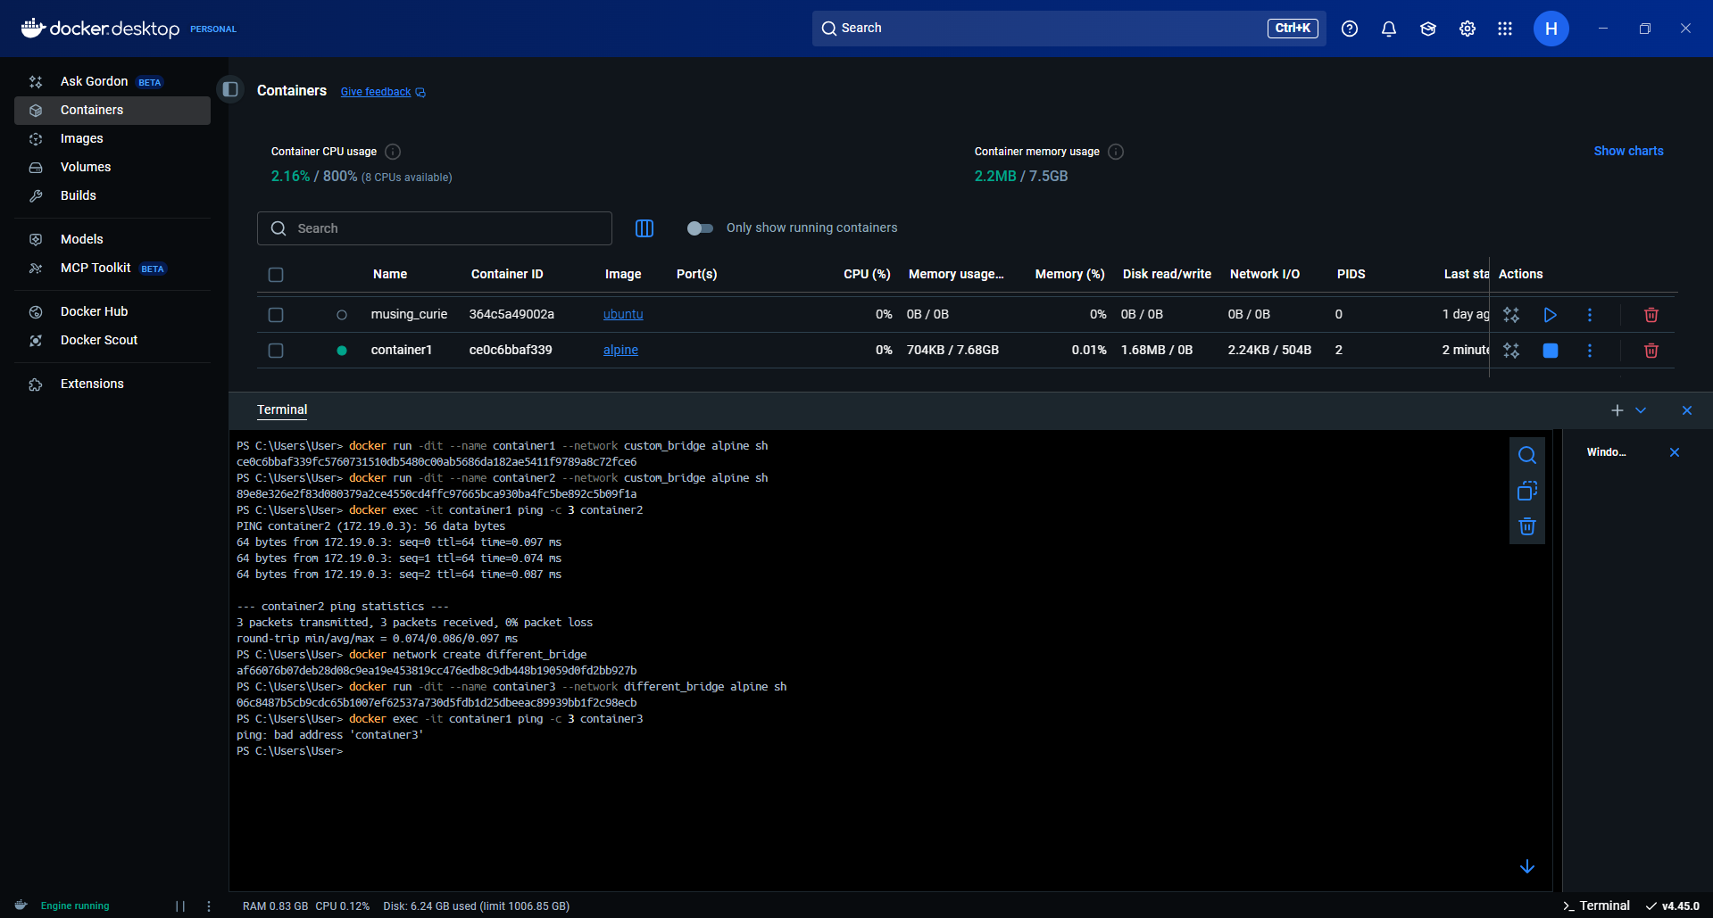

9. Docker Compose (Part 2 – Advanced)

Add environment variables using a .env file

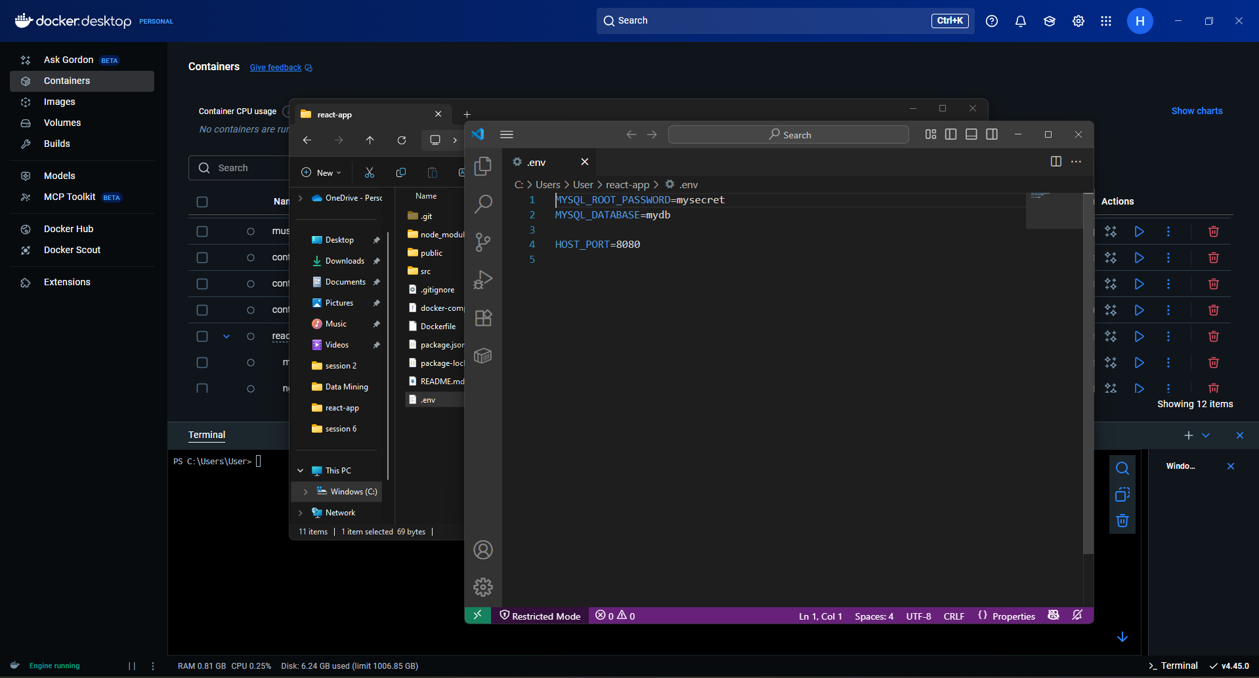

Add volume mappings for persistence and define custom networks in docker-compose.yml

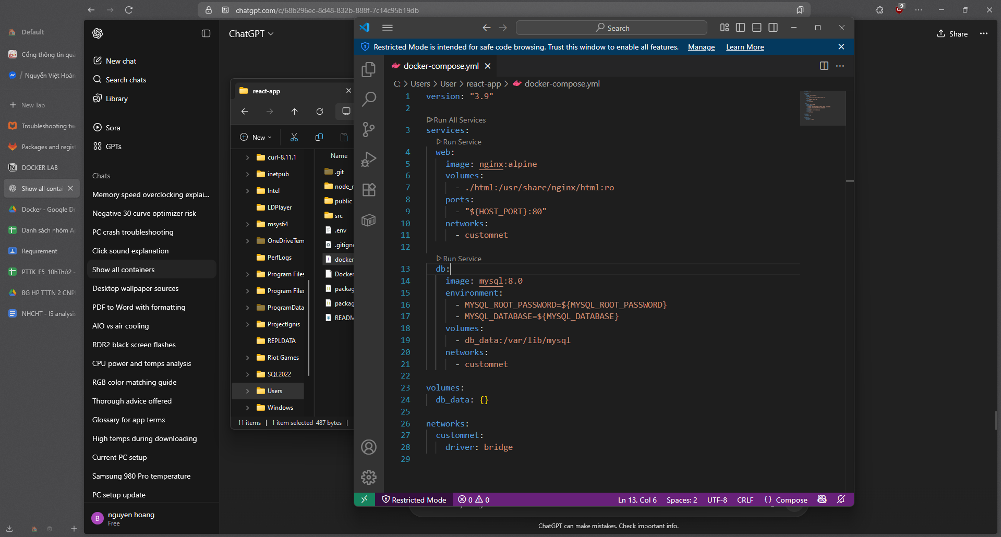

Scale services with docker compose up --scale web=3

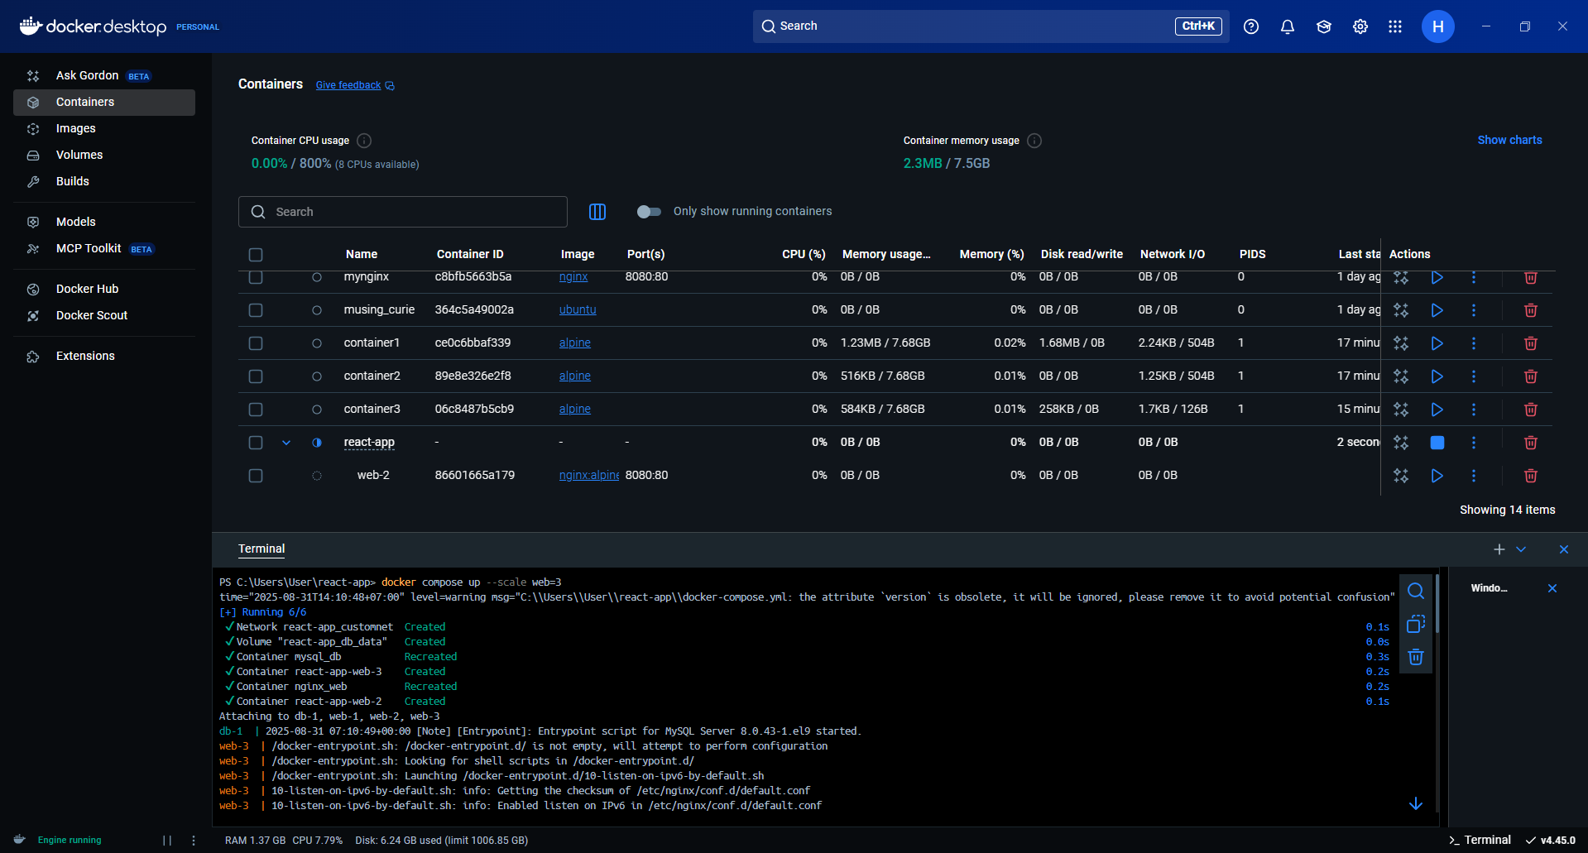

Check all the volume

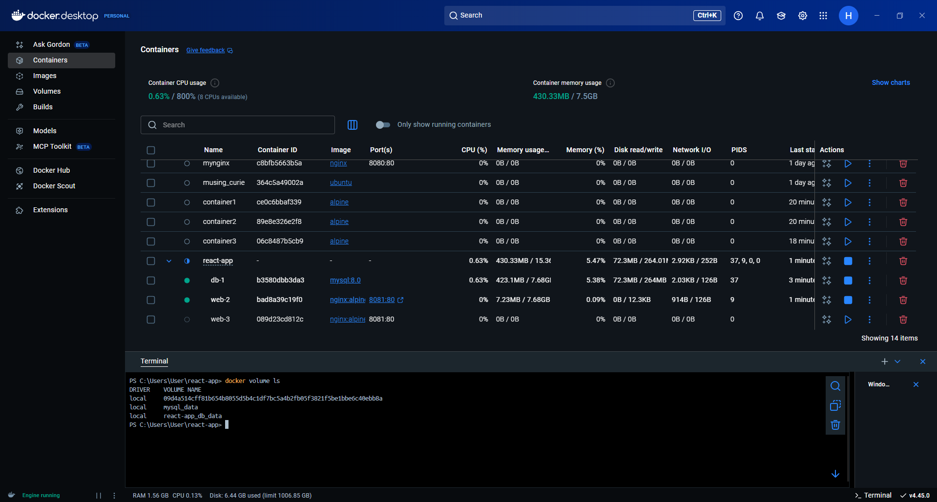

10. Advanced – Build & Push with GitLab CI/CD

Create new GitLab repo

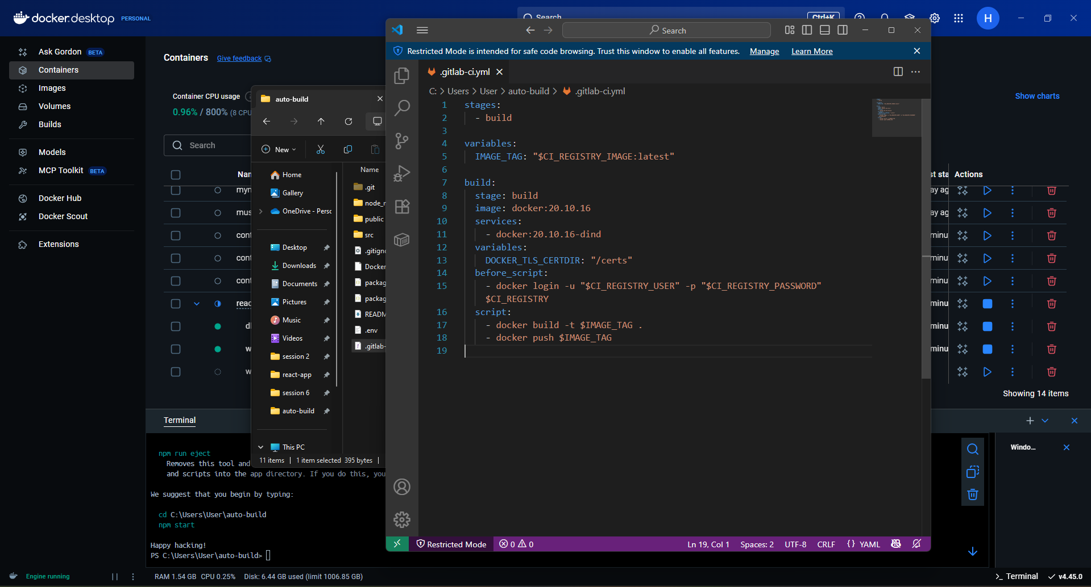

Add a Dockerfile (from Step 4) to your repo.

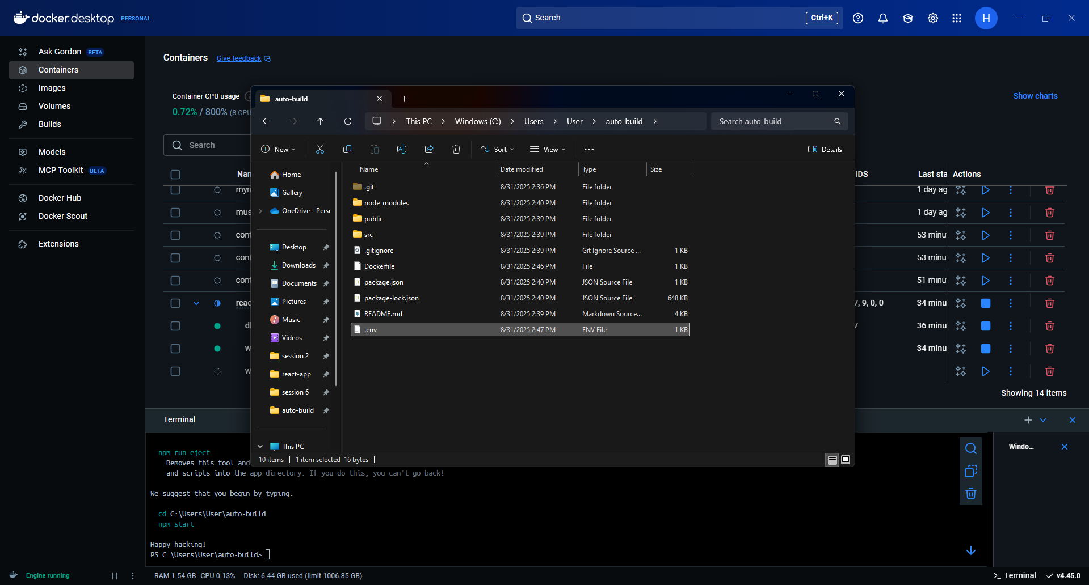

Commit and push to GitLab

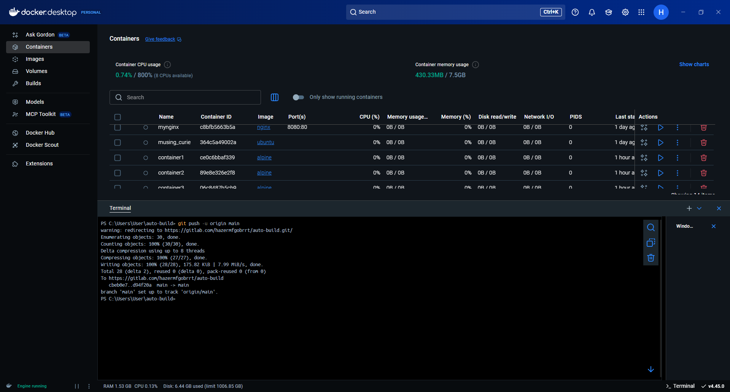

Check GitLab CI/CD pipeline

